CSS BRITISH HISTORY · TOPIC 8 · QUESTION ANSWERS
The Second World War, Attlee, the Cold War and the End of Empire (1939–1979)
Every past question on the Second World War, Churchill, Attlee, the Commonwealth, decolonisation and India, Palestine and Suez, and Britain's relationship with the USA — answered in full, in simple words, with answer maps

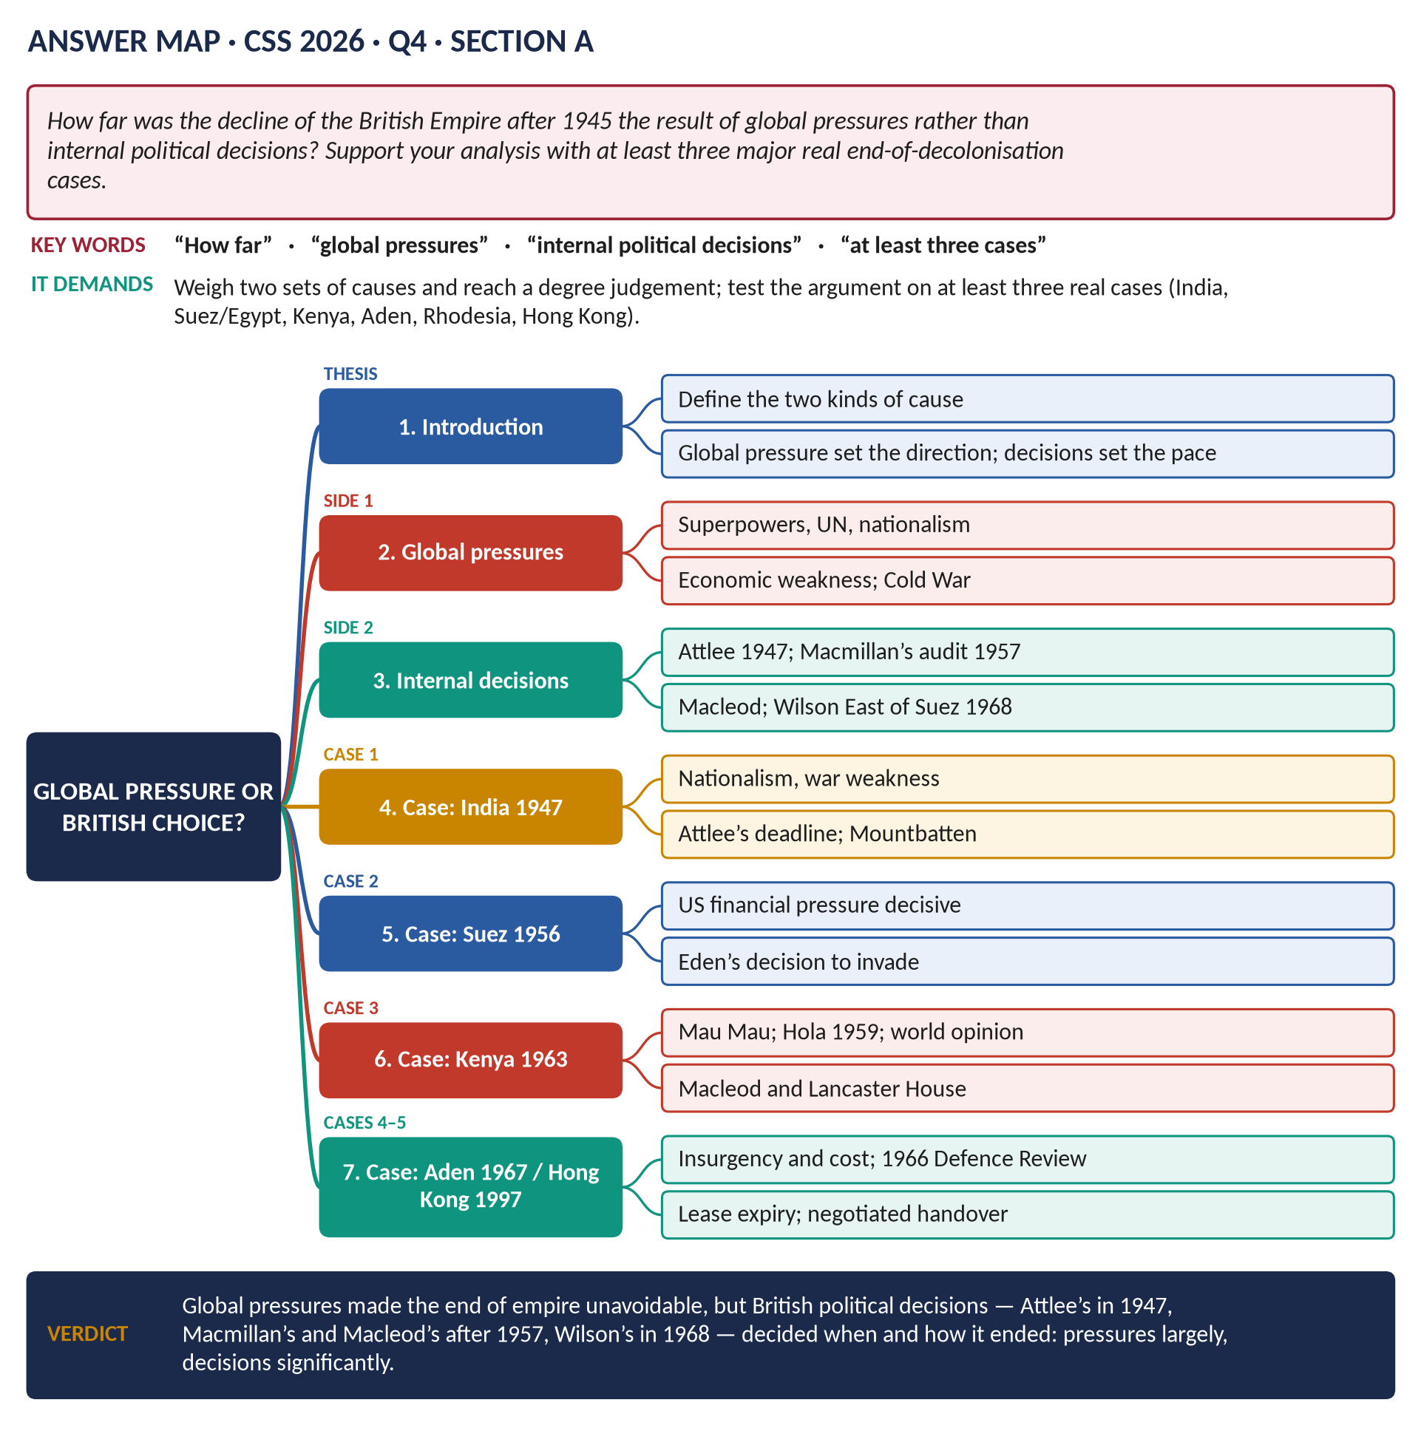
All 14 past items (2015–2026): nine full answers, one repeat shown with its adaptation, and four short notes; the ten past MCQs solved; five predicted questions with outlines.
Topic 8 of 10 · companion to T8KB (the Knowledge Base)
Contents
HOW TO USE THIS · Updating the contents
Right-click the contents → Update Field → Update entire table, before saving as PDF.

How to Use These Answers 7
Answer 1 · The Second World War: Causes, Major Developments and Aftermath 8
The model answer 9
Introduction 9
Part 1 · The causes 9
(1) The legacy of Versailles 9
(2) The Great Depression 9
(3) Hitler's aims — the central cause 9
(4) The failure of collective security and appeasement 9
(5) The Nazi–Soviet Pact (23 August 1939) 10
(6) The spark 10
Part 2 · The major developments 10
(7) 1939–1940: Axis triumph 11
(8) 1940–1941: Britain survives alone — the first turning point 11
(9) 1941: a world war — the second turning point 11
(10) 1942–1943: the tide turns 11
(11) 1943–1945: Allied victory 11
(12) The war conferences 11
Part 3 · The aftermath 12
(13) For the world 12
(14) For Britain 12
Answer 2 · Winston Churchill: Statesman, Warrior and Man of Letters 13
The model answer 14
Introduction 14
Churchill the warrior 14
(1) The young soldier (1895–1900) 14
(2) First Lord of the Admiralty (1911–15) 14
(3) The war leader (1940–45) 15
(4) Criticisms of the warrior 15
Churchill the statesman 15
(5) Before 1940 15
(6) The war statesman 15
(7) The post-war statesman 16
Churchill the man of letters 16
(8) The writer 16
(9) The orator 16
(10) The Nobel Prize (1953) 16
(11) A critical note 16
Overall assessment 17
Answer 3 · How Successfully Did Labour Tackle Post-War Britain's Problems, 1945–51? 18
The model answer 19
Introduction 19
The problems 19
(1) Economic problems 19
(2) Social problems — Beveridge's "Five Giants" 19
Tackling the economic problems 19
(3) Money 19
(4) The export drive and austerity 20
(5) Nationalisation and planning 20
(6) Full employment 20
(7) The economic crises 20
Tackling the social problems 20
(8) Want 21
(9) Disease 21
(10) Ignorance 21
(11) Squalor 21
(12) Idleness 21
The judgement — how successfully? 21
(13) The historians 22
Answer 4 · The Commonwealth: Its Development and How It Differs from the Empire 23
The model answer 24
Introduction 24
Limb 1 · How the idea developed 25
(1) Stage 1 · Self-government for the settler colonies (1839–1914) 25
(2) Stage 2 · From Dominions to equal partners (1914–1931) 25
(3) Stage 3 · The modern, multiracial Commonwealth (1947–1965) 25
(4) Stage 4 · A community of values (1971–today) 26
Limb 2 · How it differs from the British Empire 26
(5) Point-by-point comparison 26
(6) Its significance compared 27
Answer 5 · The Same Question, Set Again 28
How to reuse Answer 4 28
Answer 6 · The Motives for Decolonisation and Britain's Departure from India 29
The model answer 30
Introduction 30
Limb 1 · The motives for decolonisation 30
(1) Economic weakness 30
(2) The strength of nationalism 31
(3) The Second World War 31
(4) International pressure 31
(5) The Cold War 31
(6) British choices and ideas 31
Limb 2 · Why Britain left India 31
(7) Indian nationalism 31
(8) The Muslim League and the demand for Pakistan 32
(9) The war weakened British rule 32
(10) Loss of control 32
(11) Labour's commitment and the cost 32
Limb 2 · How Britain left India 32
(12) The failed attempts at a united India (1942–1946) 32
(13) The descent into violence (1946) 32
(14) The decision to leave (February 1947) 33
(15) The Mountbatten Plan (3 June 1947) 33
(16) Independence (August 1947) 33
(17) The consequences 33
Answer 7 · How World War II and the Cold War Triggered Decolonisation 35
The model answer 36
Introduction 36
World War II as a trigger 36
(1) It destroyed British prestige 36
(2) It made Britain poor and dependent 36
(3) It spread the ideal of self-determination 36
(4) It mobilised colonial peoples 37
(5) It strengthened nationalist movements 37
(6) It brought Labour to power 37
The Cold War as a trigger 37
(7) Two anti-colonial superpowers 37
(8) Competition for the Third World 37
(9) Handing over to moderates 37
(10) Changing British priorities 38
(11) Suez — where the two came together 38
The limits of the argument 38
Answer 8 · Global Pressures or British Decisions? The End of Empire 39
The model answer 40
Introduction 40
The two sets of causes 40
(1) Global pressures 40
(2) Internal political decisions 41
The cases 41
(3) Case 1 · India (1947) 41
(4) Case 2 · Suez (1956) 41
(5) Case 3 · Kenya (1963) 42
(6) Case 4 · Aden (1967) 42
(7) Case 5 · Hong Kong (1997) 42
The judgement 43
(8) Why global pressures were the larger cause 43
(9) Why British decisions still mattered 43
Answer 9 · The Middle East and Suez: Why Britain Withdrew from Palestine and the Canal 44
The model answer 45
Introduction 45
Part 1 · Britain in the Middle East and the Suez Crisis 46
(1) Britain's interests and position 46
(2) The road to the crisis 46
(3) The crisis 46
Part 2 · Why Britain withdrew from Palestine (1948) 46
(4) Contradictory promises 46
(5) The reasons for withdrawal 47
Part 3 · Why Britain withdrew from the Suez Canal 47
(6) The agreed withdrawal (1954–56) 47
(7) The forced withdrawal after the invasion (1956) 47
Discussion — the consequences 48
Answer 10 · Britain and America: Subservience or Partnership? 49
The model answer 50
Introduction 50
Limb 1 · Why some believe Britain was subservient 50
(1) The roots of dependence (1945–1956) 50
(2) Cold War evidence 50
(3) After 9/11 51
(4) Why the view is widely held 51
Limb 2 · My argument: partnership by choice, not subservience 51
(5) Evidence of independence during the Cold War 51
(6) Evidence of independence after the Cold War 52
(7) Explaining the pattern 52
(8) Where the critics are right 52
Short Notes 54
The Second World War (1939–1945) 54
Sir Winston Churchill (1874–1965) 54
The Suez Canal Crisis (1956) 55
The Creation of the Commonwealth 55
Part Two — The Past MCQs, Solved 57
CSS 2024 · MCQ 7 57
CSS 2024 · MCQ 11 57
CSS 2024 · MCQ 12 57
CSS 2024 · MCQ 14 57
CSS 2025 · MCQ 11 58
CSS 2025 · MCQ 13 58
CSS 2025 · MCQ 16 58
CSS 2025 · MCQ 17 58
CSS 2026 · MCQ 9 59
CSS 2026 · MCQ 19 59
Part Three — Five Predicted Questions, with Outlines 60
Predicted 1 · "Trace Britain's changing attitude towards the EEC from 1957 to 1975." 60
Predicted 2 · "Discuss the role of the war conferences in shaping the post-war world, and the creation of the United Nations." 60
Predicted 3 · "What was the post-war consensus (1945–1979), and why did it break down?" 60
Predicted 4 · "Explain Britain's role in the Cold War from 1945 to 1962." 60
Predicted 5 · "Discuss decolonisation in Africa with reference to Ghana, Kenya and Rhodesia." 61

How to Use These Answers
# | Paper | Question (short) | Answer
1 | 2023 Q6 | The Second World War: causes, developments, aftermath | Answer 1
2 | 2022 Q7 | Churchill as statesman, warrior and man of letters | Answer 2
3 | 2019 Q6 | How successfully the Attlee government tackled post-war problems | Answer 3
4 | 2015 P-II Q6 | The Commonwealth: its development; how it differs from the Empire | Answer 4
5 | 2017 Q7 | Almost identical to 2015 — how to reuse Answer 4 | Answer 5
6 | 2019 Q7 | Motives for decolonisation; why and how Britain left India | Answer 6
7 | 2024 Q6 | How WWII and the Cold War triggered decolonisation | Answer 7
8 | 2026 Q4 | Global pressures or British decisions? Three cases | Answer 8
9 | 2020 Q6 | The Middle East and Suez; why Britain left Palestine and the canal | Answer 9
10 | 2018 Q7 | Was Britain subservient to the USA, from the Cold War to 9/11? | Answer 10
11 | 2016 Q8(a) | Short note: the Second World War | Short note
12 | 2018 Q8(a) | Short note: Sir Winston Churchill | Short note
13 | 2022 Q8(b) | Short note: the Suez Canal Crisis | Short note
14 | 2024 Q7(c) | Short note: the creation of the Commonwealth | Short note

Every answer has: the question as set · its answer map · decoding the question (what the examiner wants, in plain words) · a model answer with numbered headings, figures and a verdict · why this answer scores.
TRAP — DO NOT FALL INTO IT · Three decolonisation questions — three different demands
2019 asks for motives plus the India story; 2024 asks how two wars triggered it; 2026 asks you to weigh global pressures against British decisions with case studies. The facts overlap (T8KB Chapters 7–9); the headings must come from each question's own words.

HOW TO USE THIS · If you are new to this topic
Read T8KB Part Zero and Part One first. Every hard word is explained again inside the answers.

Answer 1 · The Second World War: Causes, Major Developments and Aftermath
THE QUESTION · CSS 2023 · Q6 · Section B · 20 marks
Produce an analytical essay on the causes, major developments and aftermath of the Second World War.

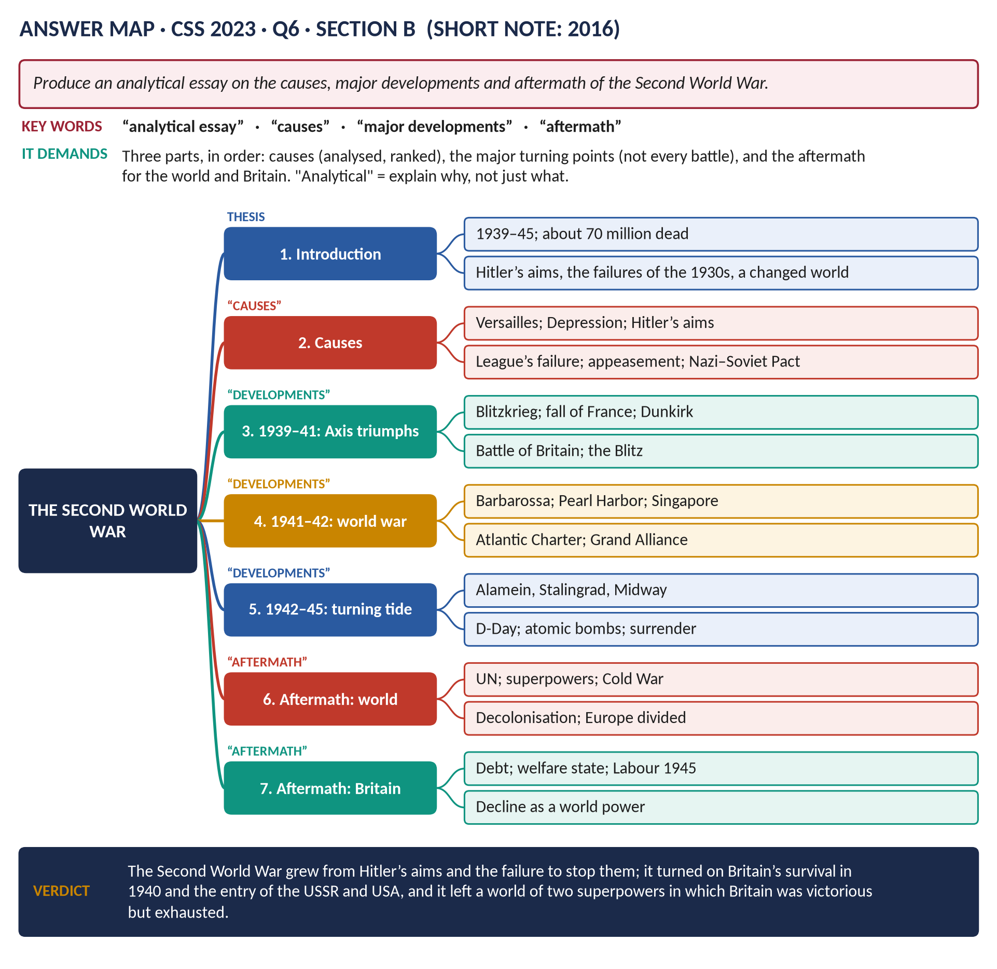
Figure 1 · The answer map for CSS 2023 · Q6 · Section B: every branch is one heading of the answer below.
DECODING THE QUESTION
"Produce an analytical essay" = not a list of events but an argument: explain why things happened and why they mattered. Three parts are named: causes, major developments (the turning points — not every battle), and aftermath (what followed — for the world and for Britain). Keep the three in order, with a thesis running through them.

The model answer

Introduction
The Second World War (1939–1945) was the most destructive conflict in history: about 70–85 million people died, including 6 million Jews murdered in the Holocaust. This essay argues that the war was caused above all by Hitler's aims of conquest, made possible by the grievances of Versailles, the Great Depression and the failure of the democracies to stop him in the 1930s; that it turned on Britain's survival in 1940 and the entry of the USSR and the USA in 1941; and that its aftermath created a new world of two superpowers, the United Nations, the Cold War and the end of European empires — a world in which Britain was victorious but exhausted.

Part 1 · The causes

(1) The legacy of Versailles
Germany resented the war guilt clause, reparations, the loss of land (the Polish Corridor, the Rhineland's demilitarisation) and disarmament. Many in Britain agreed the treaty was harsh, which later made them reluctant to resist German demands.

(2) The Great Depression
Mass unemployment (six million in Germany in 1932) brought the Nazis to power (January 1933); in Japan it strengthened the militarists; everywhere it made nations selfish and weakened the League.

(3) Hitler's aims — the central cause
Hitler wanted to destroy Versailles, unite all Germans, and conquer Lebensraum ("living space") in the East, as he had written in Mein Kampf. He rearmed (conscription, 1935), remilitarised the Rhineland (1936), annexed Austria (1938) and the Sudetenland (1938), and took Prague (March 1939).

(4) The failure of collective security and appeasement
- The League of Nations failed over Manchuria (1931) and Abyssinia (1935).
- Britain and France appeased Hitler, most famously at Munich (September 1938), convincing him that they would not fight.

(5) The Nazi–Soviet Pact (23 August 1939)
Stalin, distrusting the West after Munich, agreed with Hitler not to fight and secretly to divide Poland. Hitler could now attack Poland without fear of a Soviet war.

(6) The spark
Germany invaded Poland on 1 September 1939; Britain and France, having guaranteed Poland, declared war on 3 September.
KEY IDEA · Weighing the causes
A. J. P. Taylor (1961) argued that Hitler was an opportunist exploiting Western mistakes. Most historians (Bullock, Overy, Kershaw) reply that Hitler's ideology and aims were the essential cause; Versailles, the Depression and appeasement were the conditions that allowed him to act.

Part 2 · The major developments
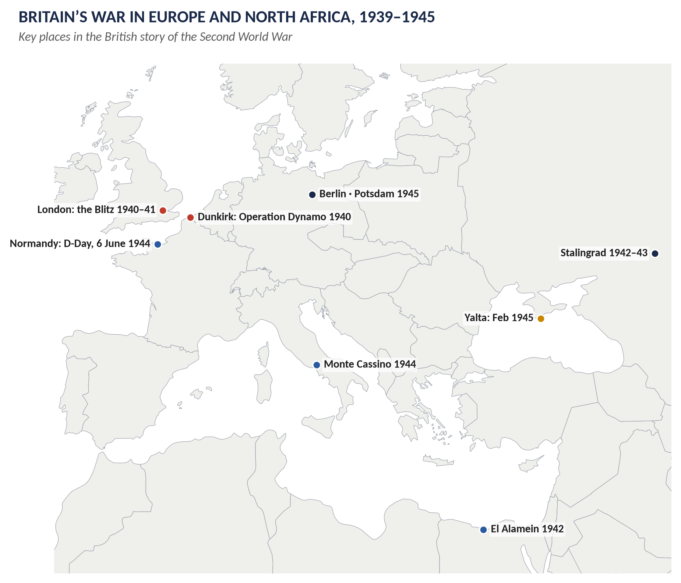
Figure 2 · Britain's war in Europe and North Africa.

(7) 1939–1940: Axis triumph
- Blitzkrieg conquered Poland in weeks; after the "Phoney War", Germany overran Norway, Denmark, the Low Countries and France (May–June 1940).
- Churchill became Prime Minister (10 May 1940); the British army was rescued from Dunkirk (Operation Dynamo, about 338,000 men).

(8) 1940–1941: Britain survives alone — the first turning point
- In the Battle of Britain (July–October 1940) the RAF defeated the Luftwaffe; Hitler abandoned the invasion (Operation Sea Lion).
- The Blitz (1940–41) failed to break British morale.
- Significance: Britain's survival kept a base for the later liberation of Europe and denied Hitler a quick victory in the West.
- Lend-Lease (March 1941) brought American supplies.

(9) 1941: a world war — the second turning point
- Operation Barbarossa (22 June 1941): Hitler invaded the USSR — a two-front war that would drain Germany.
- Pearl Harbor (7 December 1941): Japan attacked the USA, which entered the war. The Grand Alliance of Britain, the USSR and the USA now had overwhelming resources.
- Japan's conquests: Malaya, Singapore (February 1942), Burma — a disaster for British prestige in Asia.

(10) 1942–1943: the tide turns
- El Alamein (October–November 1942) in Egypt; Stalingrad (1942–43) in Russia; Midway (June 1942) in the Pacific.
- The Battle of the Atlantic won (1943).

(11) 1943–1945: Allied victory
- Italy invaded (1943); Mussolini fell.
- D-Day (6 June 1944): the Normandy landings opened the Western Front.
- Germany surrendered (8 May 1945) after Hitler's suicide.
- Atomic bombs on Hiroshima and Nagasaki (August 1945); Japan surrendered (15 August; signed 2 September).

(12) The war conferences
The Atlantic Charter (1941), Casablanca (1943: unconditional surrender), Tehran (1943), Yalta and Potsdam (1945) shaped the post-war world.
KEY IDEA · Why the Allies won
Richard Overy (Why the Allies Won, 1995): superior production (the USA and USSR), technology and intelligence (radar, Enigma), morale and leadership, and Hitler's strategic mistakes (Barbarossa, declaring war on the USA).

Part 3 · The aftermath

(13) For the world
1. The human toll: about 70–85 million dead; the Holocaust; millions of refugees.
2. The United Nations (1945): a stronger successor to the League, with the great powers on the Security Council.
3. Two superpowers: the USA and the USSR dominated the world.
4. The Cold War: Europe divided by the "Iron Curtain"; Germany split; the arms race; NATO (1949).
5. Decolonisation: the war destroyed European prestige in Asia and spread the ideal of self-determination — India (1947) and many more followed.
6. The atomic age.
7. International economic order: the IMF and World Bank (Bretton Woods, 1944); the Marshall Plan (1947).
8. European unity: the road to the EEC (1957).

(14) For Britain
1. Victory — but exhaustion: about 450,000 dead; the national debt about £21 billion; overseas assets sold; exports collapsed; dependence on US loans.
2. The welfare state: the Beveridge Report (1942) and Labour's landslide (1945) produced the NHS and National Insurance.
3. Decline as a world power: Britain was the third power, far behind the two superpowers; the empire began to go (India 1947).
4. The special relationship with the USA and membership of NATO.
5. National memory: 1940 — "their finest hour" — became central to British identity.
VERDICT · Conclusion
The Second World War was caused above all by Hitler's determination to overturn Versailles and conquer an empire in the East — made possible by the Depression, the weakness of the League and the appeasement of the democracies. Its decisive developments were Britain's survival in 1940 and the entry of the USSR and USA in 1941, which gave the Allies overwhelming strength. Its aftermath was a new world order — the UN, two superpowers, the Cold War and the end of empires — in which Britain, though victorious, was never again a first-rank power.

WHY THIS ANSWER SCORES · Why this answer scores
It is analytical — a thesis runs through all three parts and key boxes weigh causes and explain victory · the developments are organised around turning points, not a list of battles · the aftermath is divided into world and Britain · historians (Taylor, Overy) and precise dates throughout.

Answer 2 · Winston Churchill: Statesman, Warrior and Man of Letters
THE QUESTION · CSS 2022 · Q7 · Section B · 20 marks
Discuss Winston Churchill as a statesman, warrior and a man of letters.

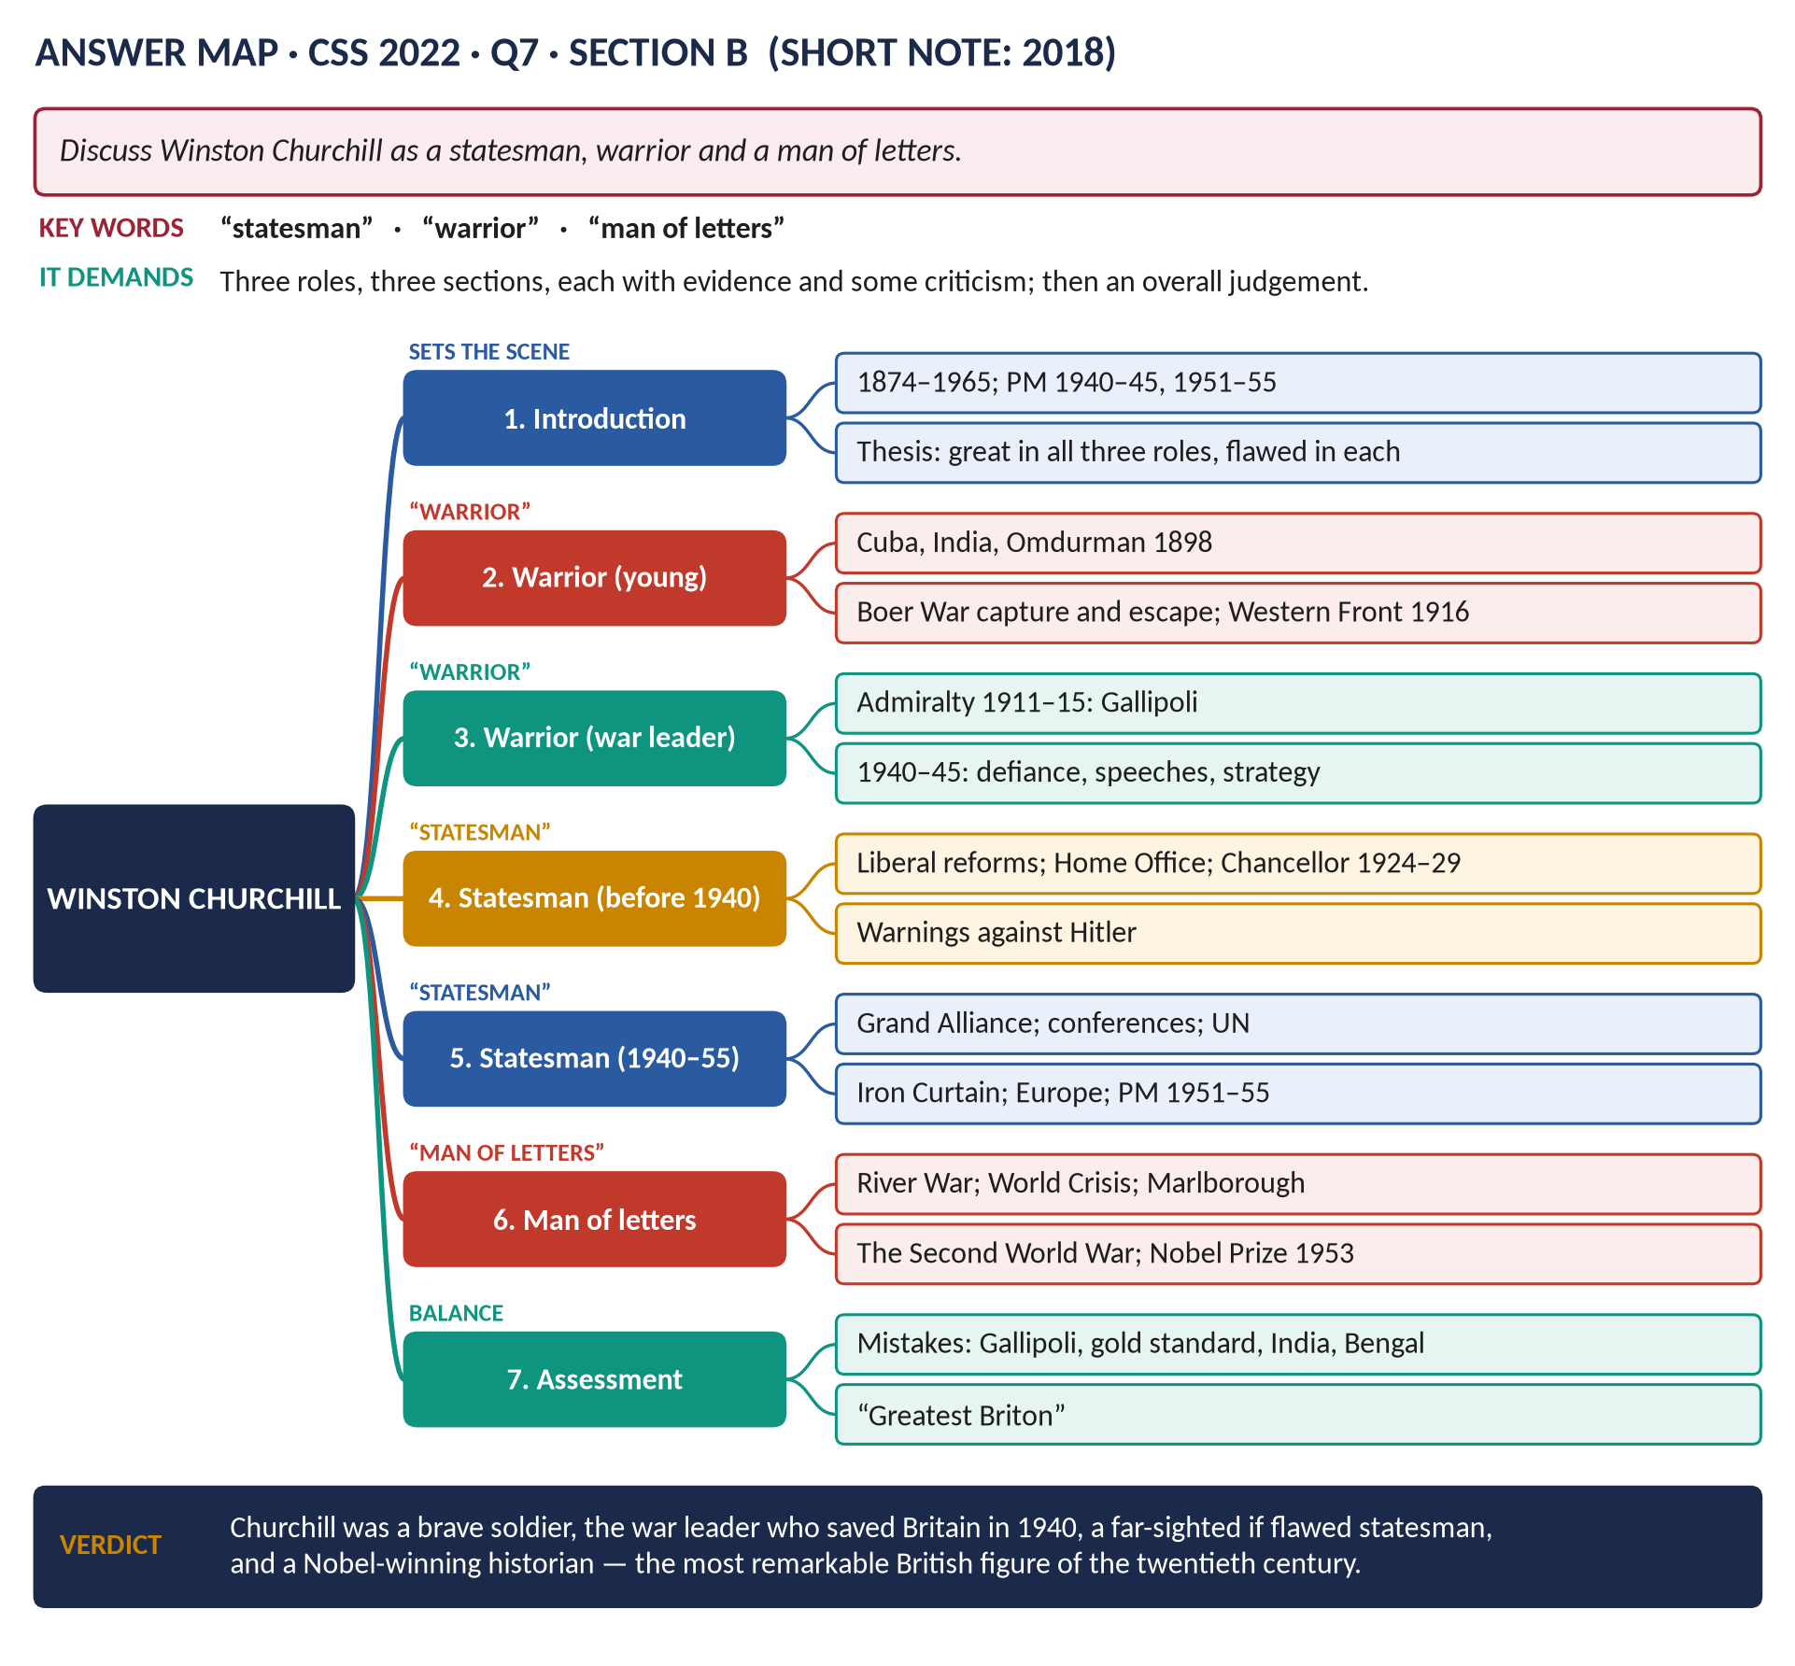
Figure 3 · The answer map for CSS 2022 · Q7 · Section B: every branch is one heading of the answer below.
DECODING THE QUESTION
"Discuss" Churchill in three roles: statesman (political leader and maker of policy), warrior (soldier and war leader), man of letters (writer, historian, orator). Give each role its own section with evidence and some criticism, then an overall judgement. A short biographical framework first helps.

The model answer

Introduction
Sir Winston Leonard Spencer Churchill (1874–1965) was a soldier, a politician for over sixty years, Prime Minister twice (1940–45 and 1951–55), and a writer who won the Nobel Prize for Literature. Few people in history have been great in so many fields. This answer argues that Churchill was an outstanding warrior — above all as the war leader who refused to surrender in 1940; a far-sighted, though often mistaken, statesman; and a gifted man of letters whose words were themselves weapons — while noting the serious errors that went with his greatness.
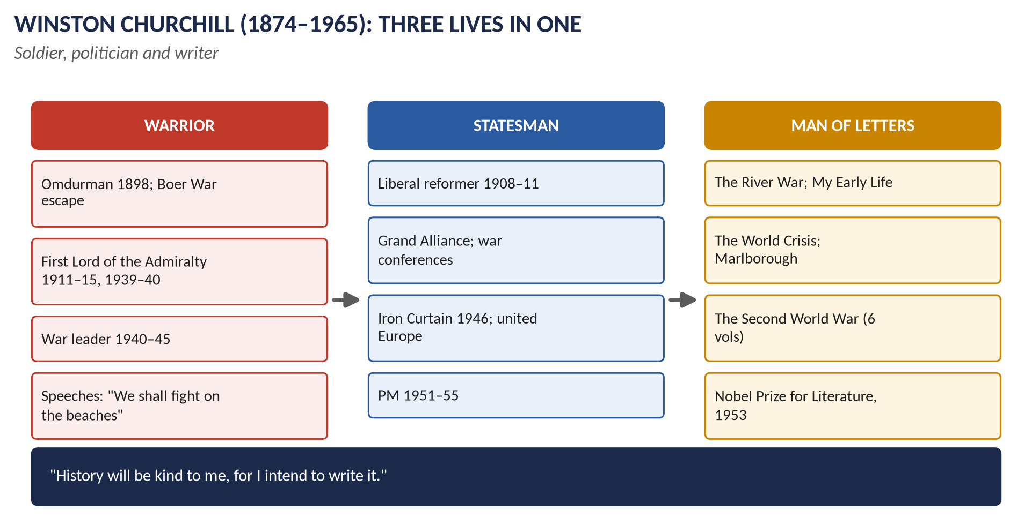
Figure 4 · Churchill's three lives.

Churchill the warrior

(1) The young soldier (1895–1900)
- Trained at Sandhurst; commissioned in the 4th Hussars.
- Saw action in Cuba (1895), on India's North-West Frontier (1897) and in the Sudan, where he rode in the charge of the 21st Lancers at Omdurman (1898).
- In the Boer War (1899) he was captured while defending an armoured train and made a daring escape from Pretoria — a national hero.

(2) First Lord of the Admiralty (1911–15)
- He modernised the Royal Navy: oil instead of coal, the naval air service, early support for the tank ("landships").
- He had the fleet mobilised and ready in August 1914.
- Gallipoli (1915): his plan to force the Dardanelles and knock Turkey out of the war failed at a cost of about 44,000 Allied dead; he was dismissed.
- He then served as a battalion commander on the Western Front (1916).

(3) The war leader (1940–45)
1. Defiance (May 1940): when France was collapsing and some ministers (Lord Halifax) wished to explore a negotiated peace, Churchill insisted on fighting on: "We shall never surrender."
2. Inspiration: his broadcasts and speeches gave the British people courage in the darkest hour.
3. Direction of the war: as Minister of Defence he drove the war machine ("Action this day"), used intelligence from Bletchley Park, and chose commanders (Montgomery, Alexander, Slim).
4. Strategy: he defended Egypt and the Mediterranean (El Alamein, North Africa, Italy), backed the bombing of Germany, and insisted on waiting until 1944 for D-Day, to avoid a disastrous failure.
5. Alliance-maker: his friendship with Roosevelt won Lend-Lease and, after Pearl Harbor, the "Germany first" strategy; he supported Stalin from the day of Barbarossa.

(4) Criticisms of the warrior
Gallipoli (1915); the Norway failure (1940); sending troops to Greece (1941), weakening North Africa; the loss of Singapore (1942); interfering with generals; Dresden (1945); his government's response to the Bengal famine (1943).

Churchill the statesman

(5) Before 1940
- Liberal reformer (1908–11): at the Board of Trade he created labour exchanges and trade boards (minimum wages); at the Home Office he reformed prisons.
- Colonial Secretary (1921–22): the Anglo-Irish Treaty; the Middle East settlement at Cairo.
- Chancellor (1924–29): widows' pensions; but the return to the gold standard (1925) harmed industry — "the biggest blunder of my life".
- The wilderness years (1929–39): he opposed Indian self-government (a mistake), but he was right about Hitler, demanding rearmament and condemning Munich as "a total and unmitigated defeat".

(6) The war statesman
- The coalition at home with Labour (Attlee as Deputy PM, Bevin at Labour).
- The Atlantic Charter (1941) and the Declaration by United Nations (1942).
- The war conferences: Casablanca, Tehran, Moscow (the "percentages agreement"), Yalta, Potsdam — keeping Britain at the "top table".
- The United Nations: Britain a permanent member of the Security Council.

(7) The post-war statesman
- The Iron Curtain speech (Fulton, 5 March 1946) warned the West of Soviet expansion and called for a special relationship with the USA — he saw the Cold War coming earlier than most.
- Europe: at Zurich (1946) he called for "a kind of United States of Europe" built on Franco-German reconciliation.
- The "three circles": Britain's role at the centre of the Commonwealth, the English-speaking world and Europe.
- Prime Minister (1951–55): he accepted Labour's welfare state; housing boomed (300,000 a year); rationing ended; he presided over the coronation (1953) and sought a summit with the Soviet leaders after Stalin's death.

Churchill the man of letters

(8) The writer
- War correspondent and military historian: The Story of the Malakand Field Force (1898), The River War (1899).
- Novelist: Savrola (1900).
- Biographer: Lord Randolph Churchill (1906); Marlborough: His Life and Times (1933–38).
- Autobiography: My Early Life (1930), a classic.
- Historian of the world wars: The World Crisis (1923–31) and The Second World War (6 volumes, 1948–53), which shaped how the world remembered the war.
- National historian: A History of the English-Speaking Peoples (1956–58).

(9) The orator
His speeches — "blood, toil, tears and sweat", "we shall fight on the beaches", "their finest hour", "so much owed by so many to so few", the "iron curtain" — are part of English literature. As the American broadcaster Ed Murrow said, "he mobilised the English language and sent it into battle".

(10) The Nobel Prize (1953)
Awarded "for his mastery of historical and biographical description as well as for brilliant oratory in defending exalted human values". He was also a talented painter.

(11) A critical note
His histories were partly self-justification — he joked, "History will be kind to me, for I intend to write it."

Overall assessment
Role | Greatness | Weaknesses
Warrior | Courage; 1940; inspiring leadership; alliances | Gallipoli, Norway, Greece, Singapore; interference
Statesman | Liberal reforms; warnings against Hitler; UN; Iron Curtain; Europe | Gold standard; India; imperial attitudes
Man of letters | Nobel Prize; the great speeches; classic histories | Histories written to justify himself

VERDICT · Conclusion
Churchill was a brave soldier and the war leader who, more than any other person, kept Britain fighting in 1940; a statesman who saw the dangers of both Hitler and Stalin before most of his contemporaries, though he made serious mistakes; and a writer and orator of such power that he won the Nobel Prize for Literature. His faults were real — Gallipoli, the gold standard, his imperial attitudes — but in all three roles together he stands as the most remarkable British figure of the twentieth century.

WHY THIS ANSWER SCORES · Why this answer scores
Three roles, three sections, each with evidence and criticism · a short biographical frame · named books, speeches and the Nobel citation make the "man of letters" section concrete · an assessment table and a balanced verdict.

Answer 3 · How Successfully Did Labour Tackle Post-War Britain's Problems, 1945–51?
THE QUESTION · CSS 2019 · Q6 · Section B · 20 marks
How successfully did the Labour government of 1945–51 tackle the economic and social problems of post-World War II Britain?

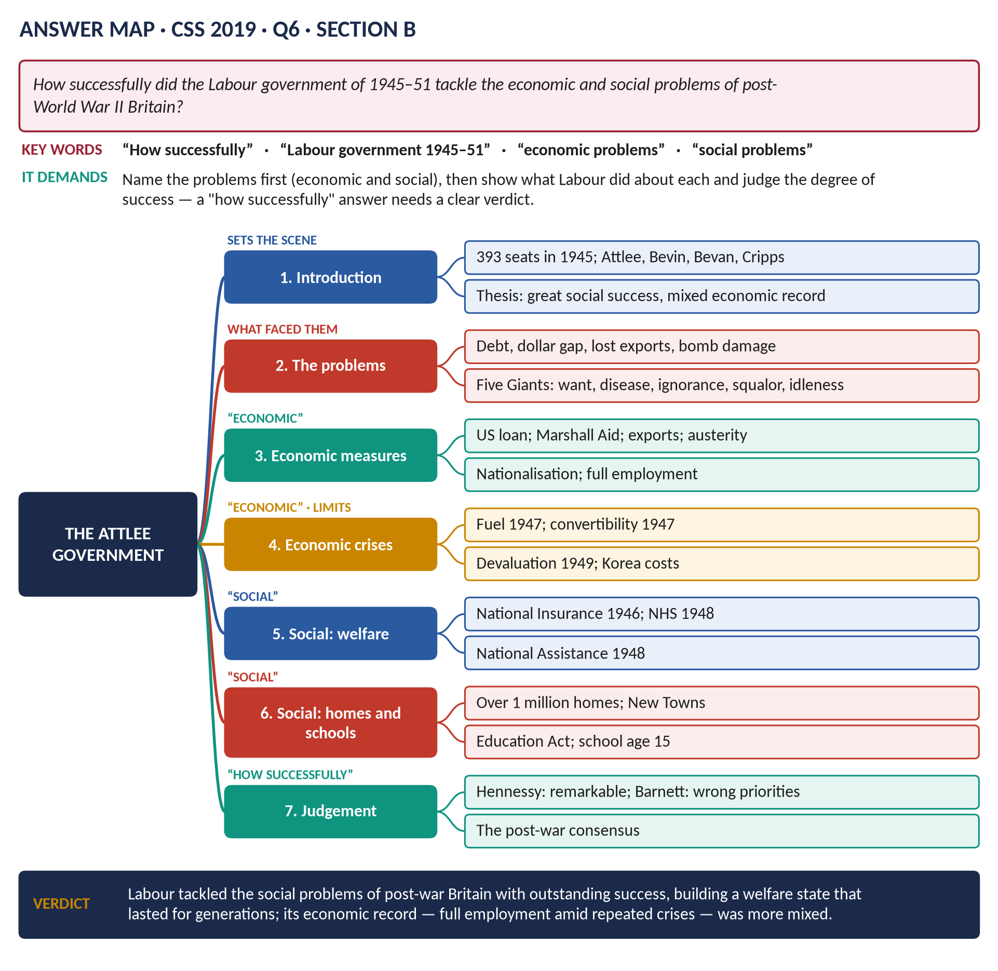
Figure 5 · The answer map for CSS 2019 · Q6 · Section B: every branch is one heading of the answer below.
DECODING THE QUESTION
"How successfully" = a judgement of degree (very, largely, partly). First name the problems — economic and social — then show what the Labour government did about each and how well it worked, with evidence and historians. Keep economic and social separate. End with a clear verdict.

The model answer

Introduction
In July 1945 the Labour Party under Clement Attlee won a landslide — 393 seats and a majority of 146 — on a promise to build a new Britain after the war. It inherited a country that was nearly bankrupt and exhausted, and a people who demanded "never again" to the poverty and unemployment of the 1930s. This answer argues that the Labour government tackled Britain's social problems with outstanding and lasting success, creating the welfare state; its handling of the economic problems was more mixed — it kept full employment and revived exports, but lurched from crisis to crisis and neglected industrial modernisation.

The problems

(1) Economic problems
1. Debt: the national debt about £21 billion; about £3.5 billion owed abroad.
2. Lost income: about £1 billion of overseas investments sold.
3. Exports: down to about a third of pre-war levels.
4. The dollar gap: Britain needed American goods but could not earn dollars.
5. The end of Lend-Lease (August 1945): Keynes warned of a "financial Dunkirk".
6. Damage and demobilisation: about 4 million homes damaged; industry to convert to peace; 5 million servicemen to return to work.
7. Overseas costs: troops in Germany, Greece, Palestine, India.

(2) Social problems — Beveridge's "Five Giants"
Want, Disease, Ignorance, Squalor and Idleness (the Beveridge Report, 1942).

Tackling the economic problems

(3) Money
- The American loan (December 1945): $3.75 billion (plus $1.25 billion from Canada), at 2 per cent interest.
- Marshall Aid (1948–51): about $2.7 billion — the largest share of any country.

(4) The export drive and austerity
- "Export or die": goods were directed abroad; by 1950 exports were about 75 per cent above pre-war levels.
- Austerity under Sir Stafford Cripps (1947–50): high taxes, controls, wage restraint (agreed with the unions), and continued rationing — even bread (1946–48).

(5) Nationalisation and planning
The Bank of England (1946), coal (1947), railways and electricity (1948), gas (1949), iron and steel (1951) — about 20 per cent of the economy — to plan the economy and improve conditions in key industries.

(6) Full employment
Unemployment stayed at about 2–3 per cent — the great fear of a return to the 1930s did not come true.

(7) The economic crises
1. The fuel crisis (February 1947): the coldest winter for a century; coal shortages; power cuts; about 2 million temporarily unemployed.
2. The convertibility crisis (July–August 1947): making the pound convertible (a condition of the US loan) caused a run on reserves; convertibility was suspended after five weeks.
3. Devaluation (September 1949): the pound cut from $4.03 to $2.80.
4. The Korean War (1950): heavy rearmament strained the economy and led to health charges (1951), causing Bevan's resignation.

Tackling the social problems
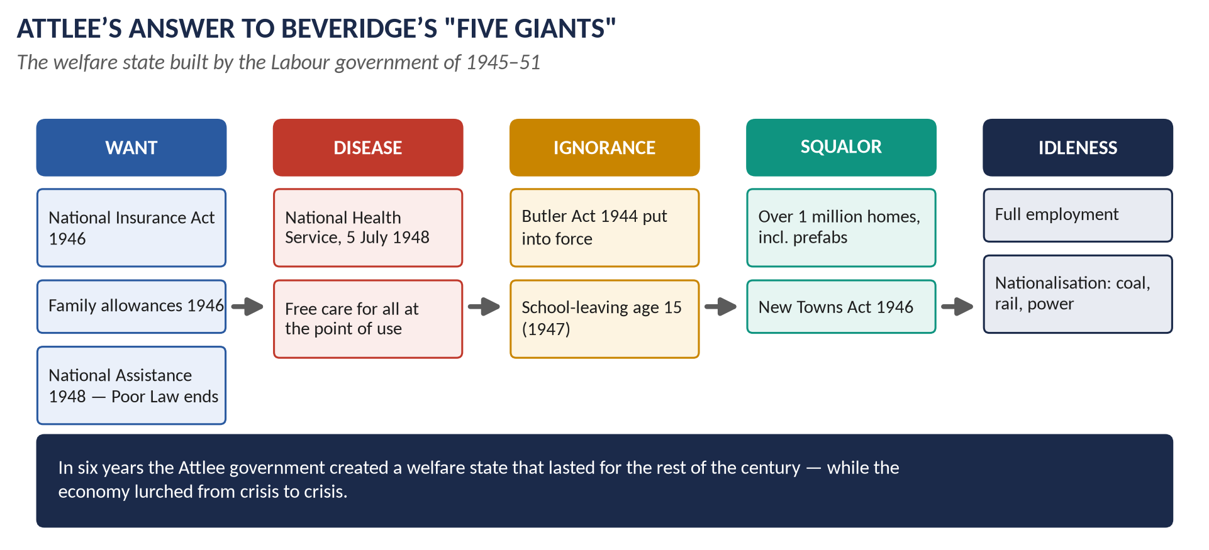
Figure 6 · Labour's answer to the Five Giants.

(8) Want
- Family Allowances (paid from 1946): 5 shillings a week for each child after the first.
- The National Insurance Act (1946): a single compulsory scheme for everyone — old-age pensions, sickness, unemployment, maternity, widows' and funeral benefits.
- The Industrial Injuries Act (1946).
- The National Assistance Act (1948): a safety net for all others — the end of the Poor Law after 350 years.

(9) Disease
The National Health Service began on 5 July 1948: free doctors, hospitals, dentists and opticians for everyone, paid from taxation. Aneurin Bevan won over the doctors by allowing private practice and paying consultants well. In the first year about 8 million dental patients and 5 million pairs of spectacles were supplied — showing the huge hidden need.

(10) Ignorance
The Butler Education Act (1944) was put into effect: free secondary education for all; the school-leaving age raised to 15 (1947); many new schools.

(11) Squalor
- About 1 million new homes by 1951 — mostly council houses — plus about 157,000 "prefabs".
- The New Towns Act (1946): Stevenage, Harlow, Crawley and others.
- The Town and Country Planning Act (1947).
- But housing was slow at first because of shortages of materials and labour, and there was still a large shortage in 1951.

(12) Idleness
Full employment throughout — the greatest single social achievement after the NHS.

The judgement — how successfully?
Successes | Failures and limits
The welfare state: NHS, National Insurance, National Assistance — lasting and popular | Repeated crises: 1947 (twice), 1949, 1951
Full employment | Austerity and rationing longer than in the war — public weariness
Exports recovered; Marshall Aid used well | Housing targets missed; quality variable
About 1 million homes; New Towns | Nationalised industries not modernised; little new investment
A new consensus — the Conservatives accepted it all | Defence spending (Korea, the bomb) strained the economy; party split in 1951

(13) The historians
- Peter Hennessy (Never Again, 1992) and Kenneth O. Morgan (Labour in Power, 1984): a remarkable government, probably the most successful in modern British history.
- Correlli Barnett (The Audit of War, 1986; The Lost Victory, 1995): Labour built a "New Jerusalem" of welfare that Britain could not afford, while failing to modernise industry, education and training — the roots of later decline.
VERDICT · Conclusion
The Attlee government tackled Britain's social problems with outstanding success: in six years it defeated Beveridge's Five Giants and built a welfare state — above all the National Health Service — that became the foundation of British life for generations. Its economic record was more mixed: it kept full employment, revived exports and avoided a slump, but it lurched through the crises of 1947, 1949 and 1951, prolonged austerity, and did too little to modernise industry. It was, overall, highly — though not completely — successful.

WHY THIS ANSWER SCORES · Why this answer scores
It names the problems first (economic and social) · each problem is matched to Labour's measures · the economic crises are faced honestly · a success/failure table and the Hennessy v Barnett debate lead to a verdict of degree ("highly — though not completely"), exactly what "how successfully" asks.

Answer 4 · The Commonwealth: Its Development and How It Differs from the Empire
THE QUESTION · CSS 2015 · Q6 · Paper II · 20 marks
How has the idea of the British Commonwealth of Nations developed? In what ways does its significance differ from the term British Empire?

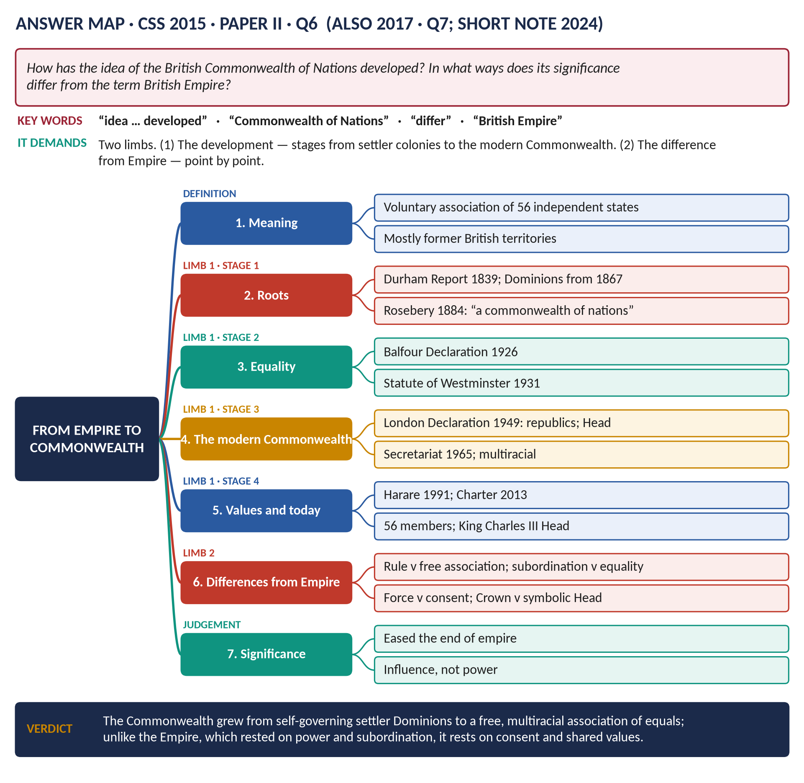
Figure 7 · The answer map for CSS 2015 · Q6 · Paper II: every branch is one heading of the answer below.
DECODING THE QUESTION
Two limbs. (1) "How has the idea of the British Commonwealth of Nations developed?" — trace the stages from the self-governing colonies to the modern Commonwealth. (2) "In what ways does its significance differ from the term British Empire?" — compare the two point by point: their basis, status, government, the Crown, force, purpose, membership. A clear definition first.

The model answer

Introduction
The Commonwealth of Nations is today a voluntary association of 56 independent and equal countries — almost all once part of the British Empire — that cooperate on the basis of shared values, with the British monarch as their symbolic Head. It grew over more than a century: from the self-government of the settler colonies, through the equality of the Dominions (1926–31), to the modern, multiracial Commonwealth of free republics and monarchies (from 1949). Where the British Empire was built on power and subordination, the Commonwealth rests on consent and equality.
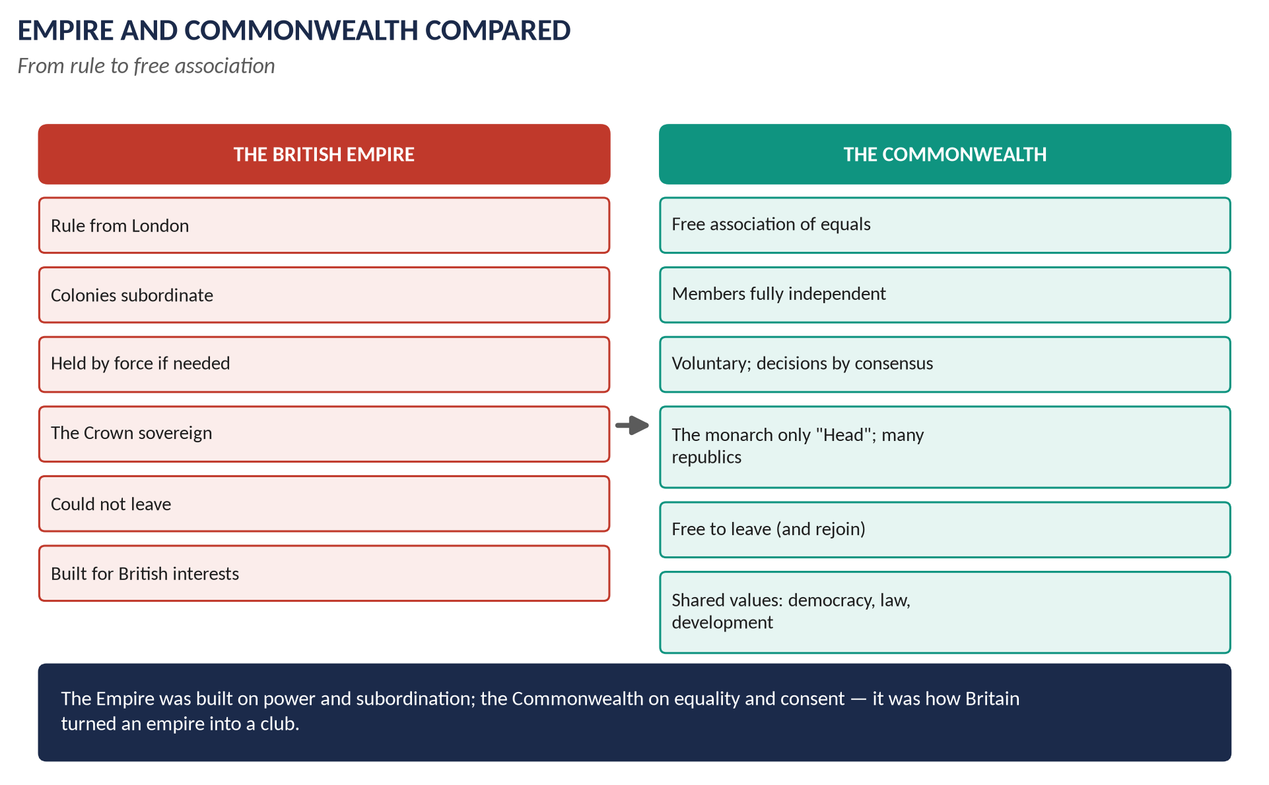
Figure 8 · Empire and Commonwealth compared.

Limb 1 · How the idea developed

(1) Stage 1 · Self-government for the settler colonies (1839–1914)
- The Durham Report (1839), after rebellions in Canada (1837), recommended responsible government — colonial governments answerable to their own elected assemblies, not to London.
- The Dominions — self-governing colonies of mostly British settlers: Canada (1867), Australia (1901), New Zealand (1907), Newfoundland (1907), South Africa (1910).
- The idea is named: Lord Rosebery (1884) said the Empire was becoming "a commonwealth of nations".
- Colonial Conferences (from 1887; Imperial Conferences from 1907) brought the prime ministers together.

(2) Stage 2 · From Dominions to equal partners (1914–1931)
- The First World War: the Dominions sent over a million men; they signed the Treaty of Versailles and joined the League of Nations in their own right.
- Jan Smuts of South Africa used the phrase "British Commonwealth of Nations" (1917); it appeared in the Anglo-Irish Treaty (1921), which made the Irish Free State a Dominion.
- Chanak (1922): the Dominions refused to follow Britain automatically into war.
- The Balfour Declaration (1926) declared Britain and the Dominions "autonomous communities within the British Empire, equal in status, in no way subordinate one to another in any aspect of their domestic or external affairs, though united by a common allegiance to the Crown, and freely associated as members of the British Commonwealth of Nations".
- The Statute of Westminster (11 December 1931) made this law: the Dominions were fully sovereign states.

(3) Stage 3 · The modern, multiracial Commonwealth (1947–1965)
- India, Pakistan and Ceylon (1947–48) became members — the first Asian, non-white members.
- The London Declaration (April 1949): India wanted to become a republic but remain a member. The Commonwealth prime ministers agreed that republics could stay, accepting the King as "the symbol of the free association of its independent member nations and as such the Head of the Commonwealth". The word "British" was dropped. This is the creation of the modern Commonwealth.
- Decolonisation brought in new African, Asian and Caribbean members from 1957 (Ghana, Malaya) onwards; the old white Dominions became a minority.
- South Africa left in 1961 because other members condemned apartheid — showing the new Commonwealth stood for racial equality.
- The Commonwealth Secretariat (1965): an independent organisation in London, with its own Secretary-General (Arnold Smith of Canada) — no longer run by the British government.

(4) Stage 4 · A community of values (1971–today)
- The Singapore Declaration (1971): peace, liberty, racial equality.
- The Gleneagles Agreement (1977): a sporting boycott of apartheid South Africa.
- The Harare Declaration (1991): democracy, human rights, good government; members can be suspended (Nigeria 1995, Pakistan 1999, Zimbabwe 2002).
- The Commonwealth Charter (2013): sixteen core values.
- Members with no British past: Mozambique (1995), Rwanda (2009), Gabon and Togo (2022).
- Today: 56 members with about 2.7 billion people; King Charles III Head since 2022; the Commonwealth Games, scholarships, trade and development programmes, and support for small states (climate change).
Year | Milestone
1839 | Durham Report: responsible government
1867 | Canada, the first Dominion
1884 | Rosebery: "a commonwealth of nations"
1926 | Balfour Declaration: equality
1931 | Statute of Westminster: sovereignty
1949 | London Declaration: republics; Head of the Commonwealth
1961 | South Africa leaves over apartheid
1965 | Commonwealth Secretariat
1991 | Harare Declaration
2013 | Commonwealth Charter

Limb 2 · How it differs from the British Empire

(5) Point-by-point comparison
Point | British Empire | Commonwealth
Basis | Conquest, settlement, treaty — power | Voluntary association — consent
Status of members | Colonies subordinate to Britain | All members equal and sovereign
Government | Ruled or supervised from London: Colonial Office, Viceroys, Governors | Each governs itself; an independent Secretariat serves all
The Crown | The sovereign ruler of all | A symbolic Head; most members are republics (e.g. India, Pakistan) or have their own monarchs
Force | Held by armies when necessary (1857, Mau Mau) | No force; members may leave and rejoin (South Africa, Pakistan)
Decisions | Made by Britain | Made by consensus at meetings (CHOGM)
Purpose | British trade, strategy and prestige | Cooperation, development, democracy, shared values
Membership | Only British possessions | Includes states never ruled by Britain (Mozambique, Rwanda)
Character | British-led and racially hierarchical | Multiracial; most members in Africa, Asia, the Caribbean and Pacific

(6) Its significance compared
- The Empire meant power: the largest empire in history, giving Britain world influence, trade and military bases.
- The Commonwealth means influence and partnership: a network for diplomacy, trade, education and shared values.
- A bridge: the Commonwealth allowed Britain to turn the end of empire into an evolution rather than a defeat, and allowed new states to keep useful links.
- Moral leadership: the fight against apartheid and white-minority rule in Rhodesia.
- Limits: it has no binding powers; its importance to Britain fell when Britain joined the EEC (1973); some call it a relic of empire, and debates over slavery reparations (Samoa, 2024) show the Empire's legacy is still contested.
VERDICT · Conclusion
The idea of the Commonwealth developed in stages — from the responsible government of the settler colonies (1839), through the equality of the Dominions (1926, 1931), to the free, multiracial association of republics and monarchies created by the London Declaration of 1949 and built on shared values since. It differs from the Empire in every essential: the Empire rested on power, subordination and British rule; the Commonwealth rests on consent, equality and cooperation. Its significance lies not in power but in partnership — it was the means by which Britain turned an empire into a club.

WHY THIS ANSWER SCORES · Why this answer scores
A clear definition first · the development traced in four stages with key documents quoted (Balfour 1926) and a milestone table · the difference from the Empire set out point by point in a table and then discussed as significance · balance through the limits of the Commonwealth.

Answer 5 · The Same Question, Set Again
THE QUESTION · CSS 2017 · Q7 · Section B · 20 marks
What do you understand by the British Commonwealth of Nations and how did it develop? How does it differ from the term British Empire?

DECODING THE QUESTION
The full question: "What do you understand by the British Commonwealth of Nations and how did it develop? How does it differ from the term British Empire?" This is almost exactly 2015 P-II Q6 (Answer 4). The only extra demand is "What do you understand by" — a clear definition and explanation of the Commonwealth's nature first.

How to reuse Answer 4
1. Open with a fuller definition (one paragraph): the Commonwealth is a voluntary association of 56 independent, equal states, most once British, with the monarch as symbolic Head; it works through the Secretariat (1965), the biennial Commonwealth Heads of Government Meeting (CHOGM), and shared values set out in the Harare Declaration (1991) and the Charter (2013); it has no binding powers; its members include republics and states never ruled by Britain.
2. Explain the name: "British Commonwealth of Nations" (Smuts 1917; Treaty 1921; Balfour 1926) became simply the "Commonwealth of Nations" after 1949.
3. Then write Answer 4 — sections (1)–(4) for "how did it develop", sections (5)–(6) for "how does it differ".
4. Conclusion as in Answer 4.
WHY THIS ANSWER SCORES · Why this works
The examiner set the same question two years apart; your prepared answer carries over, with a stronger definition section for "what do you understand by".

Answer 6 · The Motives for Decolonisation and Britain's Departure from India
THE QUESTION · CSS 2019 · Q7 · Section B · 20 marks
What were the motives behind Britain's move to decolonisation after 1945? Also explain why and how the British left India in 1947.

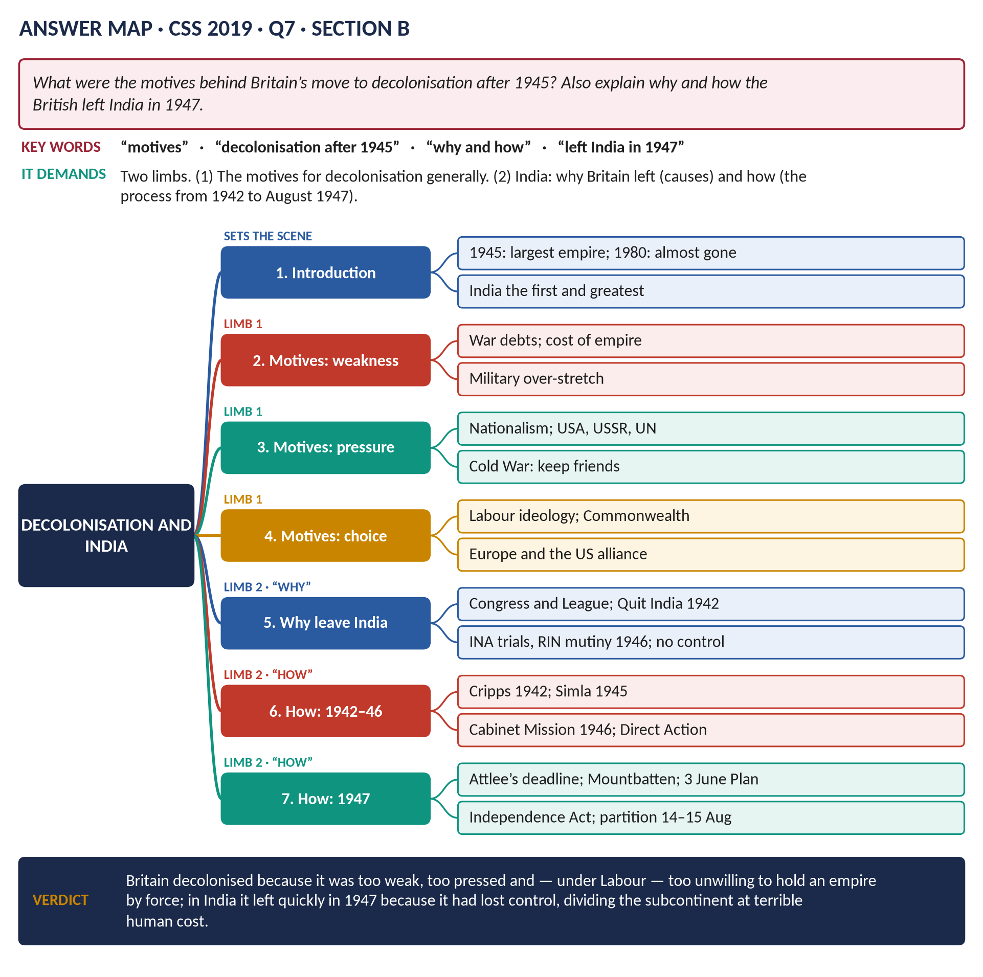
Figure 9 · The answer map for CSS 2019 · Q7 · Section B: every branch is one heading of the answer below.
DECODING THE QUESTION
Two limbs. (1) "What were the motives behind Britain's move to decolonisation after 1945?" — the reasons why Britain chose (or was forced) to give up its empire in general. (2) "Explain why and how the British left India in 1947" — why (the causes specific to India) and how (the process, step by step, from the war to August 1947). Keep the two limbs separate.

The model answer

Introduction
In 1945 the British Empire was still the largest in the world, ruling about 700 million people. By the early 1970s almost all of it had gone. Britain's move to decolonisation — giving independence to its colonies — was driven by economic weakness, the strength of nationalist movements, the effects of the Second World War, the pressure of the USA, the USSR and the United Nations, the needs of the Cold War, and the choices of British governments. India, the "jewel in the crown", was the first and greatest case: Britain left in August 1947 because it had lost the will and the means to rule, and it left in a hurry, partitioning the subcontinent at a terrible human cost.

Limb 1 · The motives for decolonisation
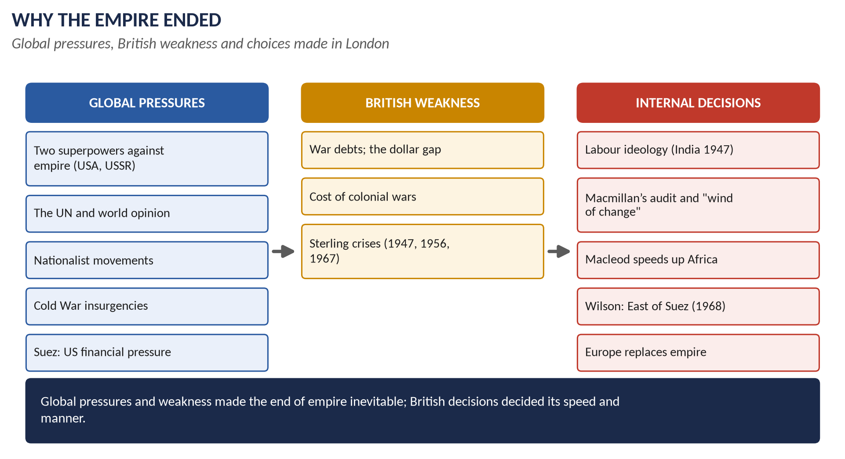
Figure 10 · Why the Empire ended.

(1) Economic weakness
- Britain ended the war with a debt of about £21 billion, dependent on American loans.
- Holding colonies by force was expensive: the emergencies in Malaya (1948–60), Kenya (1952–60), Cyprus (1955–59) and Aden (1963–67) cost money and lives.
- Repeated sterling crises (1947, 1949, 1956, 1967) forced cuts in overseas commitments.
- Macmillan's audit (1957) asked whether each colony was worth keeping — many were not.

(2) The strength of nationalism
Nationalist movements with mass support — the Indian National Congress and Muslim League, Nkrumah in the Gold Coast, Kenyatta in Kenya, Tunku Abdul Rahman in Malaya — made colonial rule impossible without constant force.

(3) The Second World War
- The fall of Singapore (1942) destroyed the myth of British invincibility.
- The Atlantic Charter (1941) proclaimed the right of peoples to choose their government.
- Millions of colonial soldiers fought and expected their reward.
- India was promised independence (Cripps, 1942).

(4) International pressure
- The USA was hostile to old empires (Roosevelt; later Eisenhower at Suez).
- The USSR backed "national liberation" movements.
- The United Nations: the Charter and the Declaration on the Granting of Independence (1960) made colonialism illegitimate.

(5) The Cold War
Britain needed to hand power to moderate, pro-Western leaders before communists could exploit discontent (Malaya); colonial wars damaged the West's image; resources were needed for NATO and nuclear weapons.

(6) British choices and ideas
- Labour's anti-imperial beliefs (Attlee on India).
- Macmillan's "wind of change" (1960) and Iain Macleod's rapid timetable for Africa.
- Suez (1956) showed that Britain could no longer act as an imperial power.
- A new focus on Europe (the EEC application of 1961).
- The Commonwealth offered a way to keep friendship and influence.

Limb 2 · Why Britain left India

(7) Indian nationalism
- The Indian National Congress (founded 1885) under Gandhi and Nehru led mass campaigns: non-cooperation (1920–22), civil disobedience and the Salt March (1930), and Quit India (August 1942), which the British crushed by imprisoning its leaders.
- By 1945 Congress commanded the support of most Hindus.

(8) The Muslim League and the demand for Pakistan
Muhammad Ali Jinnah's Muslim League passed the Lahore Resolution (23 March 1940), demanding independent states for Muslim-majority areas. In the 1945–46 elections the League won almost all the Muslim seats, proving it spoke for India's Muslims.

(9) The war weakened British rule
- Britain was exhausted and in debt — and owed India itself about £1.3 billion (the sterling balances).
- The Cripps Mission (1942) had already promised independence after the war.

(10) Loss of control
- The INA trials (1945–46): the trials of officers of Subhas Chandra Bose's Indian National Army, which had fought with Japan, provoked nationwide protest.
- The Royal Indian Navy mutiny (February 1946) in Bombay and Karachi showed that Indian armed forces could no longer be relied on.
- The Indian Civil Service and police were now mostly Indian; British officials were too few to govern.
- Communal violence was spreading beyond British control.

(11) Labour's commitment and the cost
Attlee's government believed in Indian self-government; holding India by force would have needed troops and money Britain did not have. There was also US pressure for independence.

Limb 2 · How Britain left India

(12) The failed attempts at a united India (1942–1946)
- The Cripps Mission (March 1942): dominion status after the war, with the right of provinces to stay out — rejected by Congress and the League.
- The Simla Conference (June–July 1945) under Viceroy Lord Wavell failed over the League's claim to nominate all Muslim members.
- The Cabinet Mission (March–June 1946; Pethick-Lawrence, Cripps, Alexander): its 16 May plan proposed a loose federal union with three groups of provinces (two Muslim-majority). The League accepted; Congress's interpretation (Nehru's statement that it could change the plan) led the League to withdraw.

(13) The descent into violence (1946)
- Direct Action Day (16 August 1946), called by the League: the Great Calcutta Killings — about 4,000 dead — followed by massacres in Noakhali, Bihar and later the Punjab.
- An interim government under Nehru (September 1946), joined by the League in October, could not work together.

(14) The decision to leave (February 1947)
On 20 February 1947 Attlee announced that Britain would leave India by June 1948 at the latest, and appointed Lord Mountbatten as the last Viceroy. The fixed date forced the Indian parties to agree.

(15) The Mountbatten Plan (3 June 1947)
Mountbatten concluded that a united India was impossible. The 3 June Plan provided for partition into India and Pakistan, with the provinces of Bengal and the Punjab divided; the princely states would choose to join one or the other. The date of independence was brought forward to August 1947.

(16) Independence (August 1947)
- The Indian Independence Act passed Parliament in July 1947 (royal assent 18 July).
- Pakistan became independent on 14 August (Jinnah Governor-General) and India on 15 August 1947 (Nehru Prime Minister) — both as Dominions within the Commonwealth.
- The Radcliffe Line, drawn in five weeks by Sir Cyril Radcliffe, was announced on 17 August.

(17) The consequences
- Mass violence and migration: an estimated several hundred thousand to over a million people killed; about 12–15 million displaced.
- Kashmir — a Muslim-majority state with a Hindu ruler — became the subject of war (1947–48) and lasting conflict.
- Gandhi was assassinated (30 January 1948).
- Both states stayed in the Commonwealth; India's decision to become a republic produced the London Declaration (1949).
KEY IDEA · Judging the manner of departure
For: the speed avoided a long, costly war and let Britain leave on friendly terms. Against: Mountbatten's rushed timetable (bringing the date forward ten months) and the hasty borders left no time to prepare for the migration and violence — historians such as Yasmin Khan see partition as a British failure of planning.

VERDICT · Conclusion
Britain decolonised after 1945 because it was economically too weak to hold its empire, because nationalist movements and world opinion — led by the USA, the USSR and the UN — made colonialism untenable, because the Cold War required friendly successors, and because British governments came to see the Commonwealth and Europe as better paths. India showed all these forces at once: Britain left because it had lost control and the will to rule, and it left through failed plans for unity, a fixed deadline and partition — gaining a peaceful exit for itself, but at a terrible cost to the peoples of the subcontinent.

WHY THIS ANSWER SCORES · Why this answer scores
Limb 1 gives six grouped motives with examples · Limb 2 separates why (five causes) from how (a clear chronology from Cripps to the Radcliffe Line) · the consequences and a key box on the manner of departure add judgement · dates throughout.

Answer 7 · How World War II and the Cold War Triggered Decolonisation
THE QUESTION · CSS 2024 · Q6 · Section B · 20 marks
How did World War II and the Cold War trigger the decolonization of the British Empire?

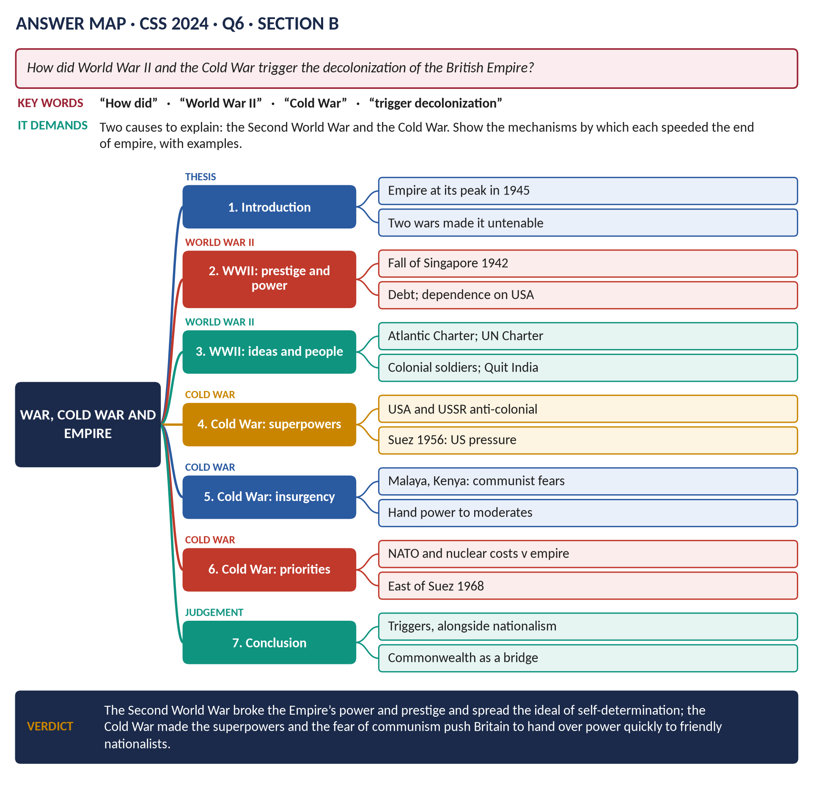
Figure 11 · The answer map for CSS 2024 · Q6 · Section B: every branch is one heading of the answer below.
DECODING THE QUESTION
"How did World War II and the Cold War trigger the decolonization of the British Empire?" — explain the mechanisms: in what ways did each of the two conflicts push Britain to give up its colonies? Give each conflict its own section with several distinct points and examples. A good answer also notes that they were triggers working alongside nationalism and British weakness.

The model answer

Introduction
In 1945 the British Empire was at its greatest extent — British forces had even reoccupied the lands Japan had taken. Yet within twenty years most of it had gone. Two great conflicts were the triggers: the Second World War (1939–45) broke Britain's power, prestige and finances and spread the ideal of self-determination; the Cold War (from 1947) set two anti-colonial superpowers against empire and made Britain hurry to hand power to friendly nationalists. Together they turned the slow growth of colonial nationalism into a rapid collapse of empire.

World War II as a trigger

(1) It destroyed British prestige
- The fall of Singapore (15 February 1942) — about 80,000 British, Indian and Australian troops surrendered to a smaller Japanese army. Churchill called it "the worst disaster … in British history". Asians had seen Europeans defeated by Asians; the myth of white invincibility was gone.
- Malaya and Burma were overrun; Japan encouraged local nationalists (the Burma National Army, the Indian National Army).

(2) It made Britain poor and dependent
- The war cost about a quarter of Britain's national wealth; it left a debt of about £21 billion, and Britain owed large sums to its own colonies (India, Egypt).
- Britain depended on American loans (1945) — and the USA was hostile to empire.
- There was simply not enough money or manpower to hold down a hostile empire.

(3) It spread the ideal of self-determination
- The Atlantic Charter (1941) promised "the right of all peoples to choose the form of government under which they will live". Churchill said it applied only to Europe; colonial nationalists and the Americans said it applied to all.
- The UN Charter (1945) committed members to develop self-government in their territories.

(4) It mobilised colonial peoples
- About 2.5 million Indians and hundreds of thousands of Africans served; soldiers returned with new ideas and expectations — many became nationalist leaders.
- Economic demands of war (production, conscripted labour) politicised colonial workers and peasants.

(5) It strengthened nationalist movements
- In India, Quit India (1942) and the promise of independence in the Cripps offer (1942) meant independence after the war was only a matter of time; India became independent in 1947 — and its example inspired others.
- In the Middle East, the war encouraged Arab nationalism and brought Jewish refugees to Palestine.

(6) It brought Labour to power
The Labour government of 1945, more sympathetic to colonial freedom, granted independence to India, Pakistan, Burma and Ceylon within three years.

The Cold War as a trigger

(7) Two anti-colonial superpowers
- The USA — itself a former colony — opposed old-style empires and wanted open markets; at Suez (1956) it forced Britain to withdraw by threatening the pound.
- The USSR presented itself as the champion of oppressed peoples and supported "national liberation" movements with arms and propaganda.

(8) Competition for the Third World
- Both superpowers competed for the friendship of the new nations of Asia and Africa. Holding colonies by force made the West look hypocritical in its struggle for "the free world".
- The United Nations, where the new states became a majority, passed the Declaration on the Granting of Independence to Colonial Countries and Peoples (Resolution 1514, December 1960).

(9) Handing over to moderates
- Britain feared that if independence were delayed, communists would lead the nationalist movements.
- Malaya: the communist insurgency (1948–60) was defeated partly by promising independence (1957) to moderate leaders (Tunku Abdul Rahman).
- In Africa, Macmillan and Macleod hurried independence to keep new states in the Western camp and the Commonwealth — the "wind of change" (1960).

(10) Changing British priorities
- The Cold War required spending on NATO, the British Army of the Rhine and nuclear weapons; an empire of bases and garrisons was a luxury.
- The 1957 Defence White Paper (Sandys) cut conventional forces; after devaluation Wilson announced withdrawal from East of Suez (1968).
- The special relationship with the USA mattered more than the empire.

(11) Suez — where the two came together
Suez (1956) showed that Britain, weakened by the war, could not act as an imperial power against the wishes of the USA in the Cold War; it speeded decolonisation dramatically (Ghana and Malaya 1957; most of Africa 1960–65).

The limits of the argument
The wars were triggers, not the only causes: colonial nationalism had deep roots (Congress, 1885), and British leaders made choices — the Commonwealth, Europe — that shaped the pace. Some colonies were held for many years after 1945 (Kenya until 1963, Aden until 1967, Hong Kong until 1997).
VERDICT · Conclusion
The Second World War triggered decolonisation by destroying British prestige in Asia, bankrupting Britain, spreading the ideal of self-determination, mobilising colonial peoples and bringing to power a Labour government ready to free India. The Cold War then set two anti-colonial superpowers against empire, made Britain hand power quickly to moderate nationalists to keep them out of the communist camp, and forced Britain to choose NATO and the American alliance over its imperial role. Together, working with colonial nationalism, the two conflicts brought the British Empire to an end within a generation.

WHY THIS ANSWER SCORES · Why this answer scores
Two conflicts, two sections, each with distinct mechanisms (prestige, finance, ideas, people, politics / superpowers, competition, moderates, priorities) · examples (Singapore, Atlantic Charter, Malaya, Suez, Resolution 1514) · a short section on limits shows balance · the verdict answers "how".

Answer 8 · Global Pressures or British Decisions? The End of Empire
THE QUESTION · CSS 2026 · Q4 · Section A · 20 marks
How far was the decline of the British Empire after 1945 the result of global pressures rather than internal political decisions? Support your analysis with at least three major real end-of-decolonisation cases.

Figure 12 · The answer map for CSS 2026 · Q4 · Section A: every branch is one heading of the answer below.
DECODING THE QUESTION
"How far" = weigh two kinds of cause and decide the degree: (a) global pressures — forces outside Britain's control (the superpowers, the UN, nationalism, economic weakness, the Cold War); (b) internal political decisions — choices made by British governments (Attlee, Macmillan, Macleod, Wilson, Thatcher). "Support your analysis with at least three major real end-of-decolonisation cases" — use specific cases as evidence (here: India 1947, Suez 1956, Kenya 1963, Aden 1967, Hong Kong 1997). Reach a clear judgement.

The model answer

Introduction
Between 1945 and 1997 Britain gave up almost the whole of the largest empire in history. Was this mainly the result of global pressures beyond its control, or of decisions made in London? This answer argues that global pressures — the rise of two anti-colonial superpowers, the United Nations, colonial nationalism and Britain's own economic weakness — made the end of empire inevitable; but British political decisions determined its timing, its manner and its outcome (peaceful or violent, inside the Commonwealth or not). The empire's decline was therefore largely the result of global pressures, but significantly shaped by internal decisions — as five major cases show.
Figure 13 · Global pressures, weakness and British decisions.

The two sets of causes

(1) Global pressures
1. The superpowers: the USA and USSR both opposed old empires.
2. The United Nations: self-determination in the Charter; Resolution 1514 (1960).
3. Colonial nationalism: mass movements in India, Africa, Asia.
4. The Cold War: communist insurgency; competition for the Third World.
5. Economic weakness: debt, dependence on the USA, sterling crises.

(2) Internal political decisions
1. Attlee (Labour): the decision to leave India (1947), Burma, Ceylon, Palestine (1948).
2. Eden: the decision to invade Suez (1956) — and to withdraw.
3. Macmillan: the audit of empire (1957); the "wind of change" (1960); the turn to Europe (1961).
4. Macleod (Colonial Secretary 1959–61): speeding African independence.
5. Wilson: the 1966 Defence Review; withdrawal from East of Suez (1968); not using force against Rhodesia.
6. Thatcher: the Hong Kong Joint Declaration (1984); Lancaster House for Zimbabwe (1979).

The cases

(3) Case 1 · India (1947)
- Global pressures: Congress and the Muslim League commanded mass support; the war left Britain in debt (including to India); the INA trials and the RIN mutiny (1946) showed loss of control; the USA favoured independence.
- British decisions: Labour's commitment; Attlee's announcement of 20 February 1947 setting a deadline; the choice of Mountbatten, who brought independence forward to August 1947 and accepted partition.
- Weighing: global and local pressures made independence unavoidable; British decisions decided when (1947, not later) and how (partition, a rushed timetable, membership of the Commonwealth).

(4) Case 2 · Suez (1956)
- Global pressures: US financial pressure — Eisenhower refused support for the pound until Britain stopped; the UN vote (64 to 5); the Soviet threat; Arab nationalism under Nasser.
- British decisions: Eden chose to invade, secretly with France and Israel (Sèvres); Eden and Macmillan (who, as Chancellor, warned of the run on sterling) chose to withdraw.
- Weighing: this is the clearest case of global pressure overriding British will — the decision to withdraw was forced by America. But it was a British decision to attempt an old-style imperial action, and Suez then led British leaders to decide to speed up decolonisation.

(5) Case 3 · Kenya (1963)
- Global pressures: the Mau Mau rising (1952–60); African nationalism across the continent (Ghana 1957, the Congo 1960); world and UN criticism, especially after the Hola camp killings (1959); the Cold War need for friendly African governments.
- British decisions: Macmillan and Iain Macleod decided in 1959–60 to move quickly to majority rule, overriding the white settlers; the Lancaster House conferences (1960, 1962); acceptance of the once-imprisoned Jomo Kenyatta as leader; independence on 12 December 1963.
- Weighing: the military defeat of Mau Mau shows Britain could have held Kenya longer by force; the decision to leave quickly was a political choice — made in response to global and African pressure.

(6) Case 4 · Aden (1967)
- Global pressures: Arab nationalism, backed by Nasser's Egypt; an insurgency (1963–67) by the NLF and FLOSY; Britain's financial crisis.
- British decisions: the 1966 Defence White Paper decided to abandon the Aden base; the hurried withdrawal in November 1967; then Wilson's decision (January 1968) to withdraw from East of Suez.
- Weighing: here economic pressure and a deliberate choice to cut commitments worked together.

(7) Case 5 · Hong Kong (1997)
- Global pressures: the lease on the New Territories expired in 1997; China's power made keeping any part of Hong Kong impossible.
- British decisions: Thatcher's negotiation of the Sino-British Joint Declaration (1984) — "one country, two systems"; Chris Patten's democratic reforms (1992–97); the peaceful handover on 1 July 1997.
- Weighing: a global reality (China and the lease) made the outcome certain; British diplomacy decided the terms.
Case | Main global pressure | Main British decision | Balance
India 1947 | Nationalism; war debts; loss of control | Attlee's deadline; Mountbatten; partition | Pressure decided that; decisions decided how
Suez 1956 | US financial pressure; UN | Eden's invasion — and withdrawal | Global pressure decisive
Kenya 1963 | Mau Mau; African nationalism; world opinion | Macleod's fast track to majority rule | Decision significant
Aden 1967 | Insurgency; sterling crisis | Defence Review 1966; East of Suez | Both
Hong Kong 1997 | China; the lease | Joint Declaration 1984 | Pressure decided; diplomacy shaped

The judgement

(8) Why global pressures were the larger cause
- Britain could not have kept its empire in a world dominated by two anti-colonial superpowers, a UN majority of new states, and nationalist movements that could make colonies ungovernable.
- Britain's economic weakness made every colonial war and base a burden.
- At Suez global pressure simply overruled a British decision.

(9) Why British decisions still mattered
- They decided the pace: India in 1947 rather than later; Africa in 1960–65 rather than the 1980s (as many officials had expected in 1950).
- They decided the manner: largely peaceful transfers within the Commonwealth, unlike France's wars in Indochina and Algeria or Portugal's in Africa.
- They decided the priorities: Macmillan's and Wilson's choices of Europe and the American alliance over empire.
- Historians: John Darwin stresses the global context ("the empire always depended on a favourable world order"); Ronald Hyam stresses the managed, deliberate nature of British decisions.
VERDICT · Conclusion
The decline of the British Empire after 1945 was largely the result of global pressures — anti-colonial superpowers, the United Nations, nationalist movements and Britain's own economic weakness — which made its end inevitable, as Suez showed most brutally. But it was not only that: British political decisions — Attlee's deadline for India, Macmillan's and Macleod's rapid African timetable, Wilson's retreat from East of Suez, Thatcher's Hong Kong treaty — decided when and how the empire ended, and explain why Britain, unlike France and Portugal, left mostly peacefully and kept its former colonies as Commonwealth partners.

WHY THIS ANSWER SCORES · Why this answer scores
It defines both kinds of cause · it uses five real cases (more than the three required), each analysed for both sides · a case table summarises the balance · the judgement answers "how far" with degree words ("largely … but significantly") and cites Darwin and Hyam.

Answer 9 · The Middle East and Suez: Why Britain Withdrew from Palestine and the Canal
THE QUESTION · CSS 2020 · Q6 · Section B · 20 marks
What do you know about the Middle East and Suez Canal Crisis? Also explain why England withdrew from Palestine and the Suez Canal. Discuss.

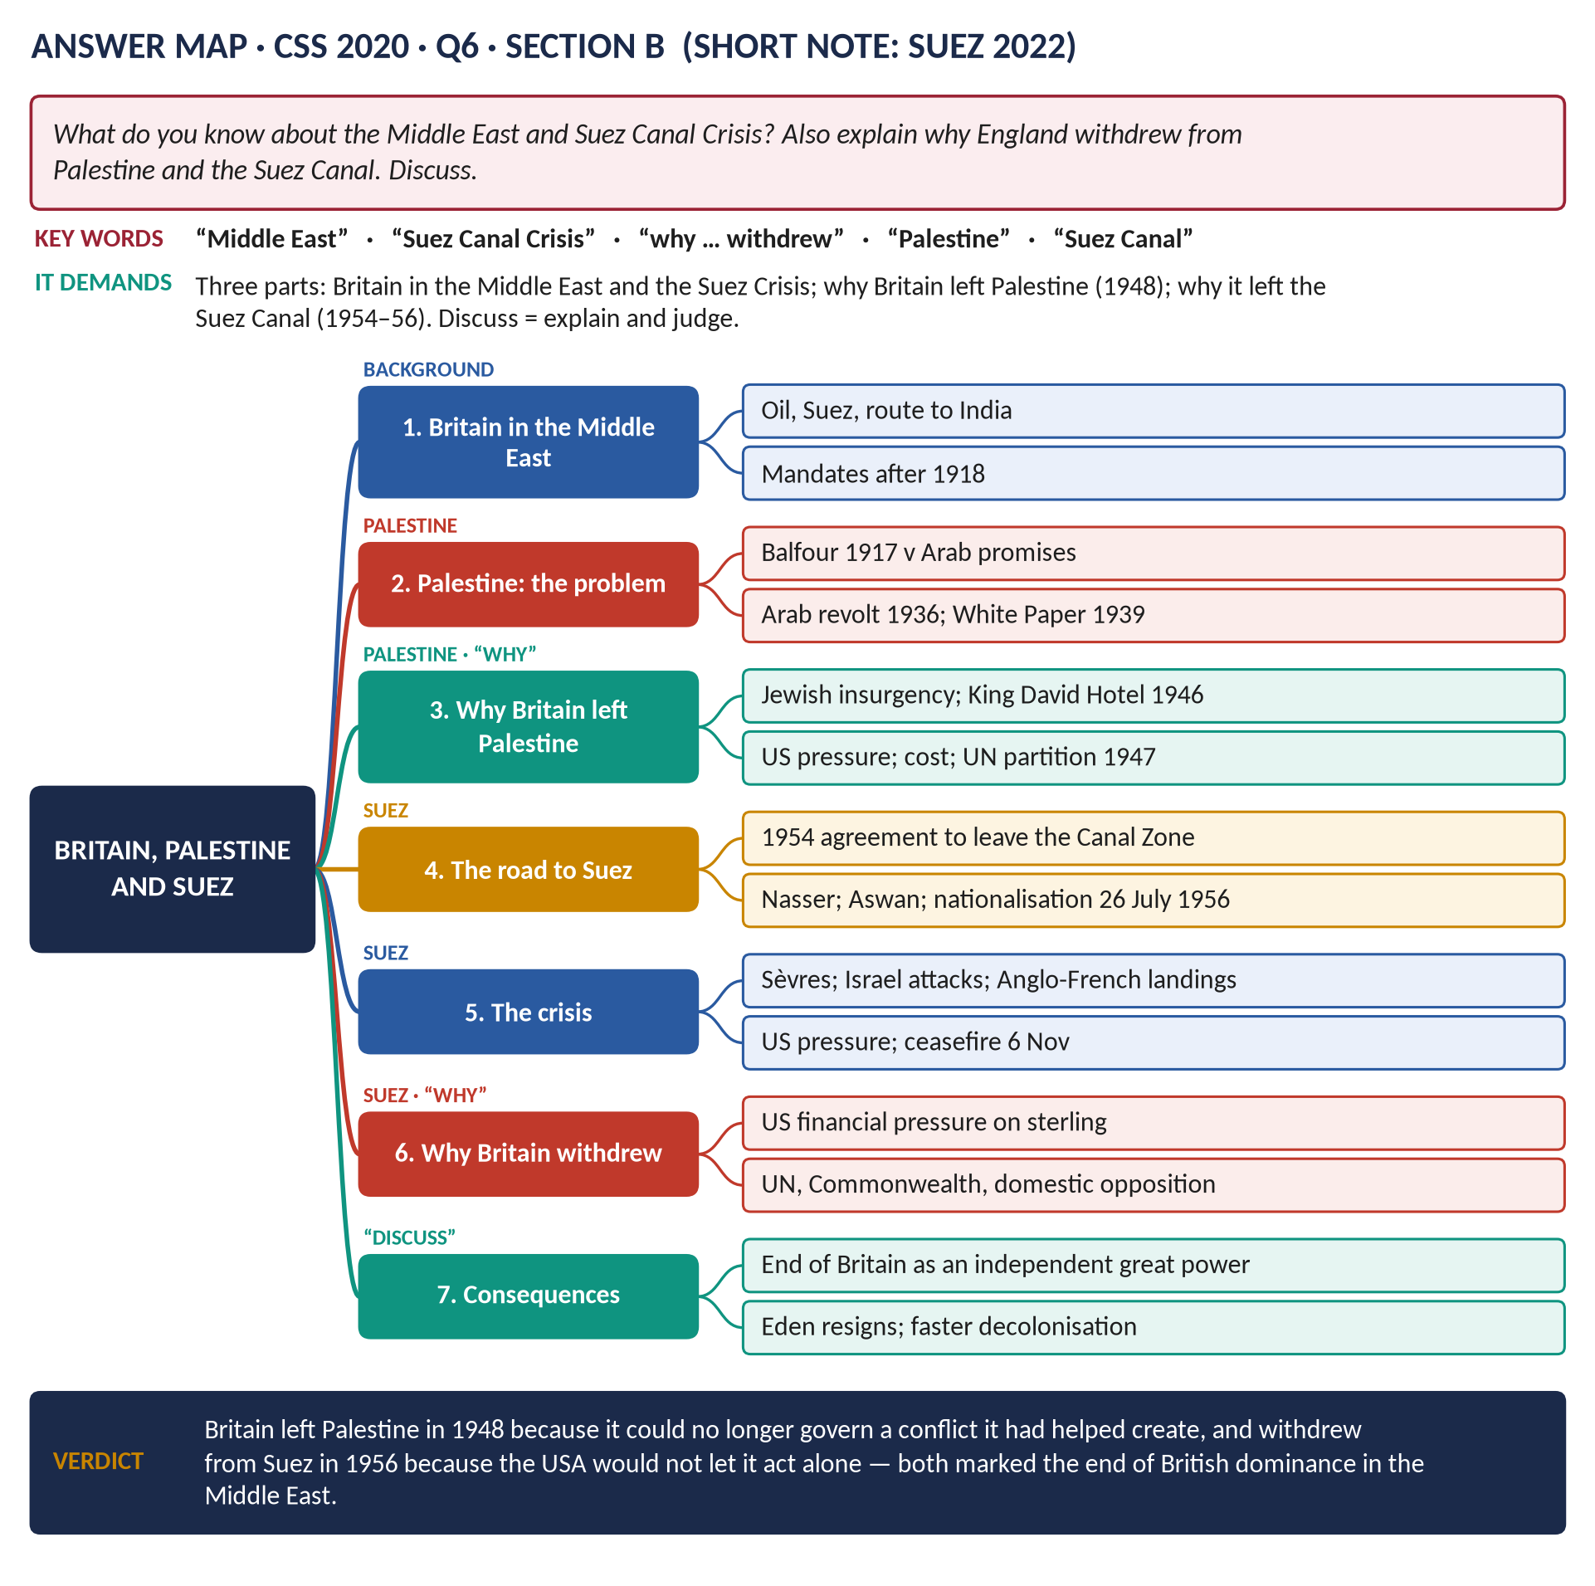
Figure 14 · The answer map for CSS 2020 · Q6 · Section B: every branch is one heading of the answer below.
DECODING THE QUESTION
Three parts. (1) "What do you know about the Middle East and Suez Canal Crisis?" — Britain's position in the Middle East and the story of the 1956 crisis. (2) "Explain why England withdrew from Palestine" (1948). (3) "… and the Suez Canal" — both the agreed withdrawal of the base (1954–56) and the forced withdrawal after the invasion (November–December 1956). "Discuss" = explain and judge.

The model answer

Introduction
For a century the Middle East was vital to Britain: the Suez Canal was the route to India and the East, and the region's oil fuelled Britain's economy. After 1918 Britain dominated the region through League of Nations mandates and treaties. But after 1945 its position collapsed. Britain withdrew from Palestine in 1948 because it could no longer govern a conflict its own promises had created, and it withdrew from the Suez Canal — first by agreement (1954–56) and then, humiliatingly, after the failed invasion of 1956 — because the United States would not allow it to act as an independent imperial power.
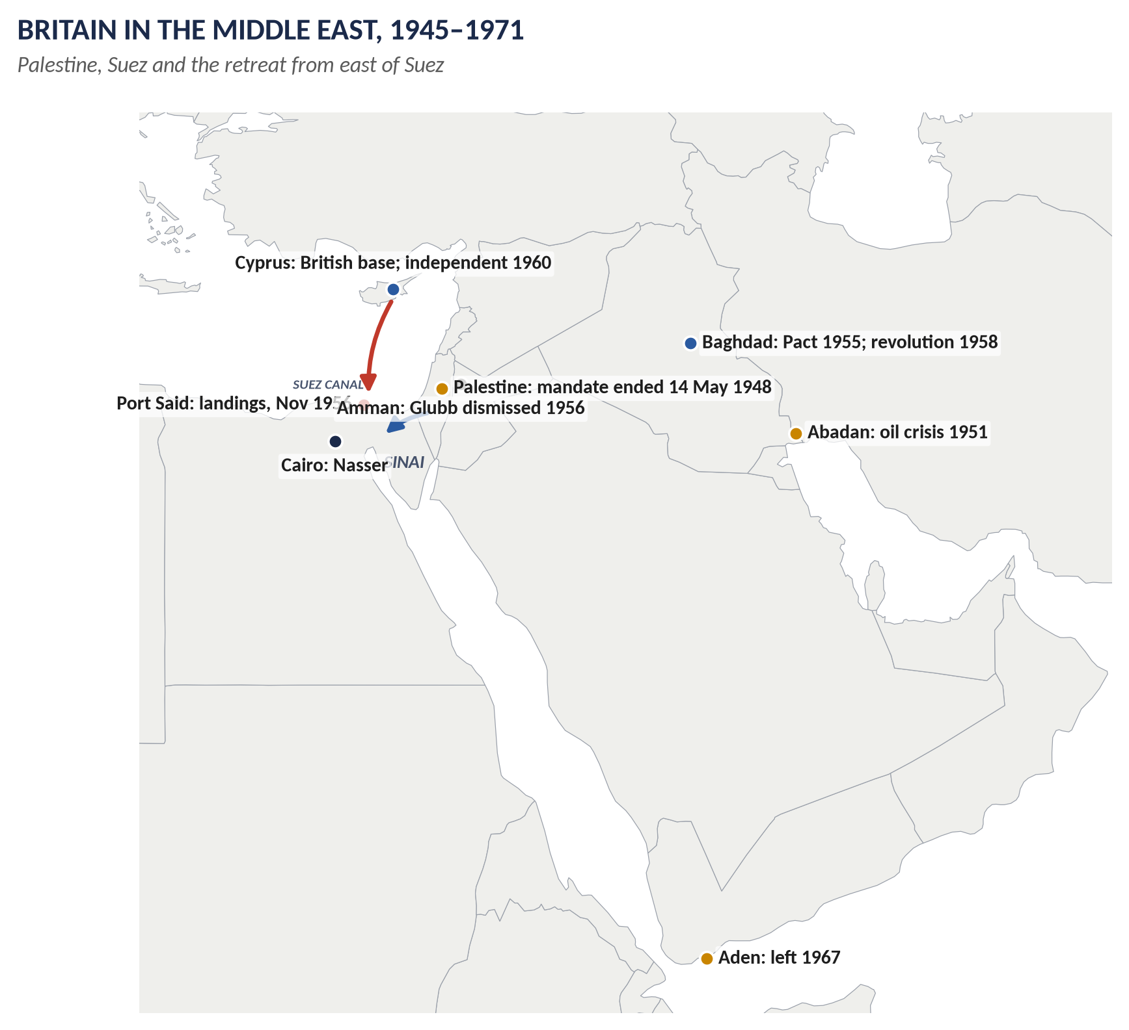
Figure 15 · Britain in the Middle East, 1945–1971.

Part 1 · Britain in the Middle East and the Suez Crisis

(1) Britain's interests and position
- The Suez Canal (opened 1869): Britain bought the Khedive's shares (1875), occupied Egypt (1882) and kept troops in the Canal Zone under the Anglo-Egyptian Treaty (1936) — about 80,000 soldiers in the largest base in the world by the early 1950s.
- Oil: Iran (the Anglo-Iranian Oil Company), Iraq, the Gulf; in the 1950s two-thirds of Western Europe's oil passed through the canal.
- Mandates after 1918: Palestine, Transjordan, Iraq.
- After 1945: Arab nationalism and the Cold War challenged British dominance — the Iranian oil crisis (1951–53), the Egyptian revolution (1952), the dismissal of Glubb Pasha in Jordan (1956).

(2) The road to the crisis
- 1952: army officers overthrew the Egyptian king; Colonel Gamal Abdel Nasser became leader (1954) — a hero of Arab nationalism.
- October 1954: Britain agreed to withdraw its troops from the Canal Zone within 20 months; the last troops left in June 1956.
- 1955: Nasser opposed the British-backed Baghdad Pact and bought Czech (Soviet-bloc) arms.
- 19 July 1956: the USA and Britain withdrew their offer to finance Nasser's Aswan High Dam.
- 26 July 1956: Nasser nationalised the Suez Canal Company, promising compensation, to pay for the dam.

(3) The crisis
- Eden, the Prime Minister, saw Nasser as a new Mussolini who must not be appeased; France wanted to stop Nasser's help to the Algerian rebels.
- The Protocol of Sèvres (22–24 October 1956): Britain, France and Israel secretly agreed that Israel would attack Egypt and Britain and France would then intervene, claiming to separate the two sides.
- 29 October: Israel invaded Sinai. 30 October: the Anglo-French ultimatum. 31 October: British and French bombing of Egyptian airfields; Nasser blocked the canal.
- 5–6 November: Operation Musketeer — Anglo-French landings at Port Said.
- 6 November: Eden accepted a ceasefire. A UN Emergency Force replaced the invaders, who left by 22 December.
- 9 January 1957: Eden resigned.

Part 2 · Why Britain withdrew from Palestine (1948)

(4) Contradictory promises
- The McMahon–Hussein correspondence (1915–16) seemed to promise the Arabs independence; the Balfour Declaration (1917) promised a Jewish national home.
- Under the mandate (1920/22) Jewish immigration grew, especially after 1933; the Arab Revolt (1936–39) followed.
- The Peel Commission (1937) proposed partition; the 1939 White Paper limited Jewish immigration to 75,000 in five years — angering the Zionists just as European Jews faced destruction.

(5) The reasons for withdrawal
1. Jewish insurgency: the Irgun and Lehi waged a campaign of bombing and assassination; the King David Hotel bombing (22 July 1946) killed 91; the hanging of two British sergeants (1947) shocked the British public.
2. No acceptable solution: Arabs and Jews wanted opposite things; any British plan was rejected by one side or both.
3. American pressure: President Truman demanded the admission of 100,000 Jewish survivors of the Holocaust; the Exodus affair (1947), in which refugees were sent back to Germany, damaged Britain's reputation.
4. Cost: about 100,000 troops were tied down at a time of economic crisis (1947).
5. Wider priorities: Britain valued its relations with the Arab states and its oil; it would not impose a solution on either side.
6. Handing it to the UN: Bevin referred the problem to the United Nations (February 1947); the UN voted for partition (Resolution 181, 29 November 1947); Britain abstained and refused to enforce it.
7. Withdrawal: the mandate ended on 14–15 May 1948. Israel was proclaimed; the first Arab–Israeli war followed; about 700,000 Palestinians became refugees.

Part 3 · Why Britain withdrew from the Suez Canal

(6) The agreed withdrawal (1954–56)
1. Cost and hostility: the Canal Zone base was expensive and under constant guerrilla attack by Egyptian nationalists (1951–52).
2. The hydrogen bomb: planners argued that a huge base was vulnerable and less useful in the nuclear age.
3. US encouragement to reach agreement with the new Egyptian government.
4. Alternative bases: Cyprus, Libya, Iraq.

(7) The forced withdrawal after the invasion (1956)
1. US opposition — the decisive reason: Eisenhower was furious at not being consulted, fearful that the invasion would drive the Arab world towards the USSR, and fighting a presidential election. The USA sponsored the UN ceasefire resolution and refused financial help.
2. The run on sterling: Britain was losing its gold and dollar reserves fast; the USA blocked an IMF loan until Britain agreed to a ceasefire. Macmillan, the Chancellor, warned that the pound could not be defended.
3. Oil: the canal was blocked and a pipeline cut; oil rationing began in Britain.
4. The United Nations: the General Assembly condemned the invasion (64 to 5).
5. The Soviet threat: the USSR threatened rocket attacks on London and Paris.
6. Divided Commonwealth: India, Canada and others opposed the invasion.
7. Opposition at home: Labour under Gaitskell, much of the press, and two ministers who resigned (Anthony Nutting, Edward Boyle).

Discussion — the consequences
- The end of Britain as an independent great power: it could not act against the USA.
- The special relationship was rebuilt by Macmillan on the understanding that Britain would never again defy America on a major issue.
- Faster decolonisation: the "wind of change".
- Nasser's triumph and the decline of British influence: Iraq's pro-British monarchy fell (1958); Britain left Aden (1967) and the Gulf (1971).
- The Eisenhower Doctrine (1957): the USA replaced Britain as the West's power in the Middle East.
- France turned to Europe and its own nuclear force.
VERDICT · Conclusion
Britain's dominance of the Middle East, built on the Suez Canal, oil and the mandates, collapsed within a decade of 1945. It left Palestine in 1948 because it could not reconcile the contradictory promises it had made to Arabs and Jews, faced a Jewish insurgency and American pressure, and could not afford the cost; it left the Suez Canal base by agreement in 1956 because it was costly and vulnerable, and then withdrew from its invasion of Egypt because the United States, by threatening the pound, forced it to. Suez was the moment when the world — and Britain itself — saw that its imperial age was over.

WHY THIS ANSWER SCORES · Why this answer scores
All three parts have separate sections · the Middle East background and the crisis are clearly dated · Palestine is explained through its roots and seven reasons for withdrawal · the Suez withdrawal covers both the agreed (1954–56) and the forced (1956) departures — a distinction most answers miss · the consequences give the "discussion".

Answer 10 · Britain and America: Subservience or Partnership?
THE QUESTION · CSS 2018 · Q7 · Section B · 20 marks
Why is it believed in certain circles that after decolonisation Britain was subservient to the US line of action during the Cold War and thereafter, down to 9/11 and subsequent years? Do you agree or not? Argue.

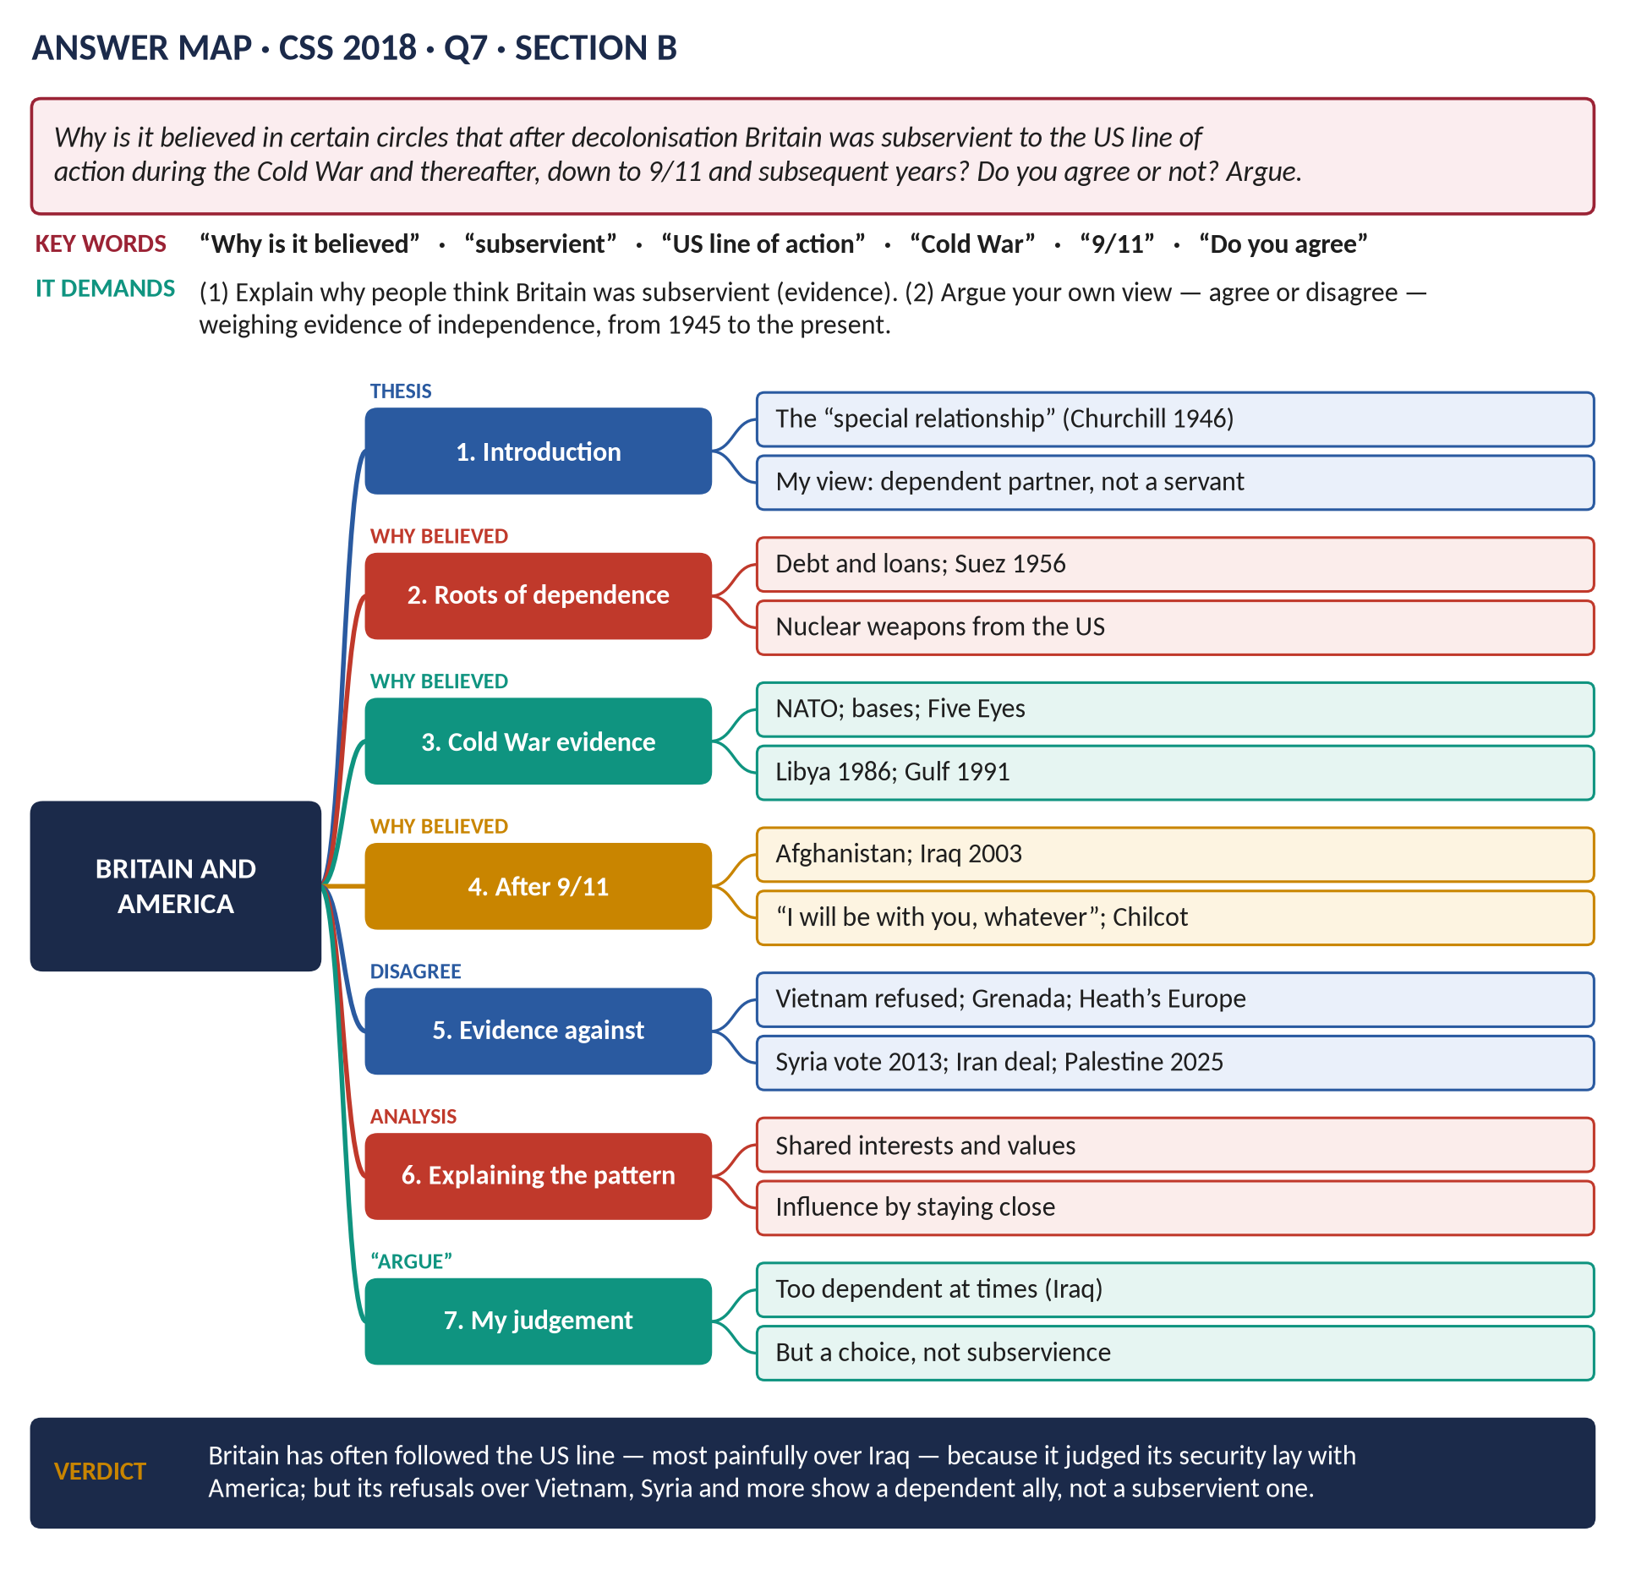
Figure 16 · The answer map for CSS 2018 · Q7 · Section B: every branch is one heading of the answer below.
DECODING THE QUESTION
Two limbs. (1) "Why is it believed in certain circles that … Britain was subservient to the US line of action during the Cold War and thereafter, down to 9/11 and subsequent years?" — explain the evidence and reasons behind this view. (2) "Do you agree or not? Argue." — give your own view, clearly, weighing the evidence of independence against the evidence of subservience, across the whole period from 1945 to the present. "Subservient" means obedient, ready to do what another wants.

The model answer

Introduction
Since 1945 Britain's closest ally has been the United States — a partnership that Churchill named the "special relationship" in 1946. Critics, especially since the Iraq War of 2003, argue that it is not a partnership of equals but a relationship of subservience: Britain, they say, simply follows the American line. This answer explains why that view is held, and argues that it is partly true but ultimately mistaken: Britain has been a dependent and sometimes too-willing partner, but its support for the USA has been a choice based on its own interests, and on several important occasions it has refused to follow.

Limb 1 · Why some believe Britain was subservient

(1) The roots of dependence (1945–1956)
- Money: Britain emerged from the war bankrupt; it depended on the American loan (1945) and Marshall Aid (1948–51).
- Security: only the USA could defend Western Europe against the USSR; Britain helped create NATO (1949) under American leadership.
- Suez (1956): when Britain acted against US wishes, Eisenhower forced it to withdraw by threatening the pound. The lesson learned by Macmillan and later leaders: never again oppose the USA on a major issue.

(2) Cold War evidence
- Nuclear dependence: after the US cancelled Skybolt, the Nassau Agreement (1962) gave Britain Polaris missiles; later Trident — Britain's "independent" deterrent depends on American missiles and technical support.
- American bases in Britain: US bombers from 1948; cruise missiles at Greenham Common (1983) despite mass protests.
- Intelligence: the UKUSA Agreement (1946) — the "Five Eyes" — tied British intelligence to American.
- Libya (1986): Thatcher allowed US bombers to attack Libya from British bases.
- The Gulf War (1991): Britain sent the largest European force to the US-led coalition.

(3) After 9/11
- "Shoulder to shoulder": after the attacks of 11 September 2001, Tony Blair pledged total support; British forces joined the invasion of Afghanistan (October 2001) and stayed until 2021.
- Iraq (2003): Blair joined the US invasion of Iraq despite:
  - about 1 million protesters in London (February 2003);
  - the failure to obtain a second UN resolution;
  - doubts about the evidence of weapons of mass destruction (the "dodgy dossier"), which were never found.
- The Chilcot Report (July 2016) revealed Blair's private note to President Bush (July 2002): "I will be with you, whatever." It found that Britain had gone to war before peaceful options were exhausted.
- Critics called Blair "Bush's poodle".
- The 2003 Extradition Treaty was criticised as one-sided in favour of the USA.

(4) Why the view is widely held
These episodes — Suez, Polaris, Iraq — suggest a pattern: when Britain disagrees, it gives way; when America goes to war, Britain follows.

Limb 2 · My argument: partnership by choice, not subservience
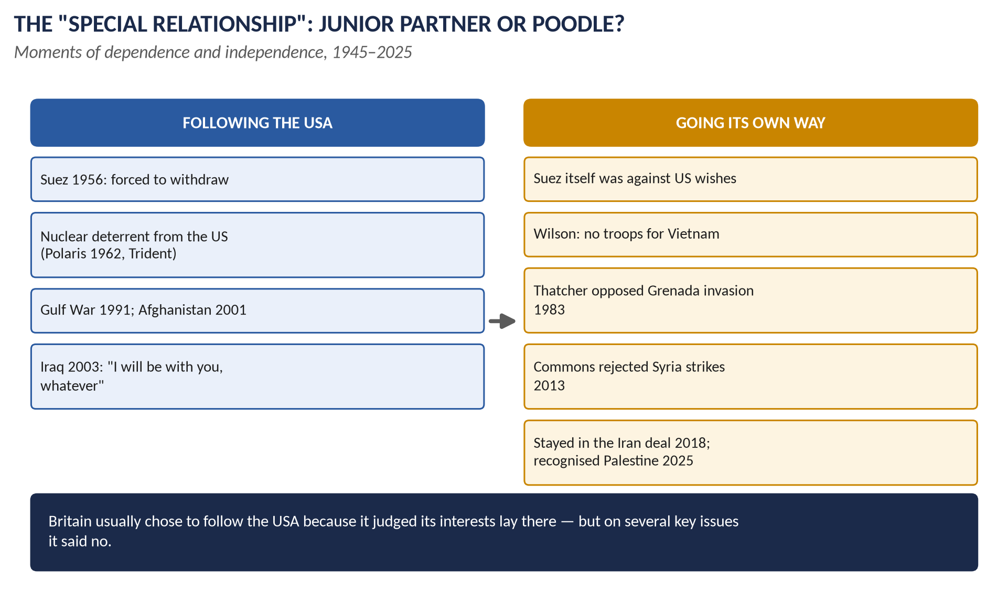
Figure 17 · Moments of dependence and independence.

(5) Evidence of independence during the Cold War
1. Suez itself (1956) was launched against American wishes.
2. Vietnam (1964–68): Harold Wilson refused President Johnson's repeated requests for British troops — even a token force.
3. Heath (1970–74) put Europe first; during the Yom Kippur War (1973) he refused the USA the use of British bases.
4. Thatcher, Reagan's closest ally, protested strongly against the US invasion of Grenada (1983), a Commonwealth country, and opposed Reagan's willingness at Reykjavik (1986) to abolish nuclear weapons.
5. The Falklands (1982): Britain acted on its own initiative; the USA, after trying to mediate, supported Britain.

(6) Evidence of independence after the Cold War
1. Blair's influence: he persuaded Bush to seek UN Resolution 1441 (November 2002) and to back a Middle East "road map" — he saw himself as shaping American policy from the inside.
2. Syria (August 2013): the House of Commons voted against joining US-led strikes (285 to 272); Britain stayed out.
3. China: Britain joined the China-led Asian Infrastructure Investment Bank (2015) despite US objections.
4. Iran: Britain stayed in the nuclear deal after President Trump abandoned it (2018).
5. Palestine: Britain recognised the State of Palestine (September 2025), against the wishes of the US administration.

(7) Explaining the pattern
- Shared interests: the USA guarantees NATO, and Britain's security depends on it.
- Shared values and history: democracy, language, law, two world wars fought together.
- A deliberate strategy: British leaders have believed that by staying close ("hugging them close") they gain influence in Washington that they would not have otherwise — and access to nuclear technology and intelligence that no other ally receives.
- Choice, not command: every British leader who followed the USA did so because they judged it right for Britain (Blair genuinely believed in the Iraq war); when a government or Parliament disagreed, Britain said no.

(8) Where the critics are right
- Britain's dependence on American nuclear and intelligence systems limits its freedom of action.
- On Iraq Britain followed too readily, with too little independent judgement — as Chilcot showed.
- After Brexit (2020), Britain relies even more on the USA — for example in the AUKUS pact (2021) — and is vulnerable to American pressure on trade (tariffs, 2025).
VERDICT · My argument
It is understandable that many see Britain as subservient to the USA: its financial dependence after 1945, its humiliation at Suez, its reliance on American nuclear weapons and above all its support for the invasion of Iraq in 2003 all point that way. But I do not agree that Britain has been subservient. It has been a dependent junior partner that usually chose to follow America because it judged its own interests lay there — and that refused to follow when it did not, over Vietnam, Grenada, Syria, the Iran deal and Palestine. The relationship is one of unequal partnership, sometimes too uncritical, but not of servitude.

WHY THIS ANSWER SCORES · Why this answer scores
Limb 1 gives the critics' case fairly, with specific evidence from 1945 to 2003 · Limb 2 makes a clear personal argument in the first person, with counter-evidence from both the Cold War and after · it explains the pattern (interests, values, strategy) and concedes where the critics are right · the verdict answers "Do you agree or not?" directly.

Short Notes

The Second World War (1939–1945)
THE QUESTION · CSS 2016 · Q8(a) · Section B · short note (10 marks)
Write a short note on: Second World War

The Second World War was fought between the Allies (Britain and the Commonwealth, France, from 1941 the USSR and the USA, China and others) and the Axis (Germany, Italy, Japan).
- Causes: Versailles; the Great Depression; Hitler's aims (Lebensraum); the failure of the League; appeasement (Munich, 1938); the Nazi–Soviet Pact (23 August 1939); the invasion of Poland (1 September 1939). Britain declared war on 3 September 1939.
- Main events: the fall of France and Dunkirk (1940); the Battle of Britain and the Blitz (1940–41); Barbarossa (June 1941); Pearl Harbor (December 1941); the fall of Singapore (1942); El Alamein and Stalingrad (1942–43); D-Day (6 June 1944); German surrender (8 May 1945); Hiroshima and Nagasaki; Japanese surrender (August 1945).
- Britain's role: under Churchill, it fought alone in 1940–41 and kept the base for the liberation of Europe.
- Cost: about 70–85 million dead worldwide, including 6 million Jews in the Holocaust; about 450,000 British dead.
- Results: the United Nations (1945); two superpowers and the Cold War; decolonisation; in Britain, the welfare state and Labour's victory (1945), and decline as a world power.
In one line: the most destructive war in history, which destroyed Nazism and made the USA and USSR the masters of a new world.

Sir Winston Churchill (1874–1965)
THE QUESTION · CSS 2018 · Q8(a) · Section B · short note (10 marks)
Write a short note on: Sir Winston Churchill

- Soldier: Sandhurst; Cuba, India, Omdurman (1898); captured and escaped in the Boer War (1899).
- Politician: Conservative MP (1900); Liberal (1904–24) — labour exchanges, Home Secretary; First Lord of the Admiralty (1911–15; Gallipoli); Chancellor (1924–29; the gold standard); the "wilderness years" warning against Hitler.
- War leader: Prime Minister from 10 May 1940; refused to surrender; speeches — "blood, toil, tears and sweat", "we shall fight on the beaches", "their finest hour", "the few"; built the Grand Alliance with Roosevelt and Stalin; the war conferences (Atlantic Charter, Tehran, Yalta, Potsdam).
- After the war: defeated in 1945; the "Iron Curtain" speech (Fulton, 1946); called for a united Europe (Zurich, 1946); Prime Minister again 1951–55.
- Writer: The River War, My Early Life, The World Crisis, Marlborough, The Second World War (6 volumes), A History of the English-Speaking Peoples; the Nobel Prize for Literature (1953).
- Criticisms: Gallipoli, the gold standard, his opposition to Indian self-government, Singapore, the Bengal famine.
- Died on 24 January 1965; a state funeral; voted the "Greatest Briton" (2002).
In one line: the soldier, statesman and writer who led Britain to survival and victory in its "finest hour".

The Suez Canal Crisis (1956)
THE QUESTION · CSS 2022 · Q8(b) · Section B · short note (10 marks)
Write a short note on: Suez Canal Crisis

- Background: the Suez Canal (1869) was Britain's route to the East and its oil lifeline; Britain agreed (1954) to withdraw its troops from the Canal Zone (they left in June 1956). Egypt's leader Nasser bought Soviet-bloc arms (1955); the USA and Britain withdrew funding for the Aswan Dam (19 July 1956).
- Nationalisation: on 26 July 1956 Nasser nationalised the Suez Canal Company.
- Collusion: the secret Protocol of Sèvres (October 1956) between Britain, France and Israel.
- Invasion: Israel attacked Sinai (29 October); the Anglo-French ultimatum (30 October); bombing (31 October); landings at Port Said (5–6 November).
- Withdrawal: the USA opposed the invasion and refused to support the collapsing pound; the UN demanded a ceasefire; the USSR threatened; Britain accepted a ceasefire (6 November) and withdrew by 22 December; a UN force took over.
- Consequences: Eden resigned (January 1957); Britain's inability to act without the USA was exposed — the end of its great-power pretensions; the special relationship was rebuilt by Macmillan; decolonisation accelerated; Nasser became the hero of the Arab world; the USA replaced Britain as the dominant Western power in the Middle East.
In one line: the crisis that ended in British withdrawal and showed the world that Britain's imperial age was over.

The Creation of the Commonwealth
THE QUESTION · CSS 2024 · Q7(c) · Section B · short note (10 marks)
Write a short note on: Creation of the Commonwealth

- Roots: the Durham Report (1839) — responsible government for the settler colonies; the Dominions: Canada (1867), Australia (1901), New Zealand (1907), South Africa (1910). Rosebery (1884) spoke of "a commonwealth of nations"; Smuts of the "British Commonwealth of Nations" (1917).
- Equality: the Balfour Declaration (1926) — Britain and the Dominions "autonomous communities … equal in status … freely associated as members of the British Commonwealth of Nations".
- Sovereignty: the Statute of Westminster (11 December 1931) made the Dominions fully independent.
- The modern Commonwealth: after India, Pakistan and Ceylon joined (1947–48), India wished to become a republic. The London Declaration (April 1949) allowed republics to remain members, with the King as "Head of the Commonwealth"; the word "British" was dropped. This created the modern, multiracial Commonwealth of Nations.
- Organisation: the Commonwealth Secretariat (1965); shared values in the Singapore (1971) and Harare (1991) Declarations and the Charter (2013).
- Today: 56 members, including states never ruled by Britain (Mozambique, Rwanda); King Charles III is Head.
In one line: the Commonwealth was created by turning a British Empire of subordinate colonies into a free association of equal nations.

Part Two — The Past MCQs, Solved

CSS 2024 · MCQ 7
Which adjective is commonly associated with London in the 1960s?
(A) Smashing | (B) Smart | (C) Swinging | (D) None of these

REMEMBER · Answer: C. Swinging
In the 1960s London was called "Swinging London" — a centre of fashion, music (the Beatles, the Rolling Stones) and youth culture; Time magazine's cover of April 1966 was "London: The Swinging City".

CSS 2024 · MCQ 11
The Bank of England was nationalised in:
(A) 1945 | (B) 1946 | (C) 1846 | (D) None of these

REMEMBER · Answer: B. 1946
The Bank of England was nationalised by the Attlee government in 1946 (the Bank of England Act 1946).

CSS 2024 · MCQ 12
Queen Elizabeth II was crowned on:
(A) 2 June 1953 | (B) 2 June 1951 | (C) 2 June 1952 | (D) None of these

REMEMBER · Answer: A. 2 June 1953
Elizabeth II became Queen on 6 February 1952 and was crowned in Westminster Abbey on 2 June 1953.

CSS 2024 · MCQ 14
Apartheid was implemented in which African country?
(A) Nigeria | (B) South Africa | (C) Niger | (D) None of these

REMEMBER · Answer: B. South Africa
Apartheid — the system of racial segregation — was imposed in South Africa from 1948; it ended in the early 1990s (Mandela elected 1994).

CSS 2025 · MCQ 11
Which British Prime Minister made the “Iron Curtain” speech famous after Winston Churchill used the term?
(A) Clement Attlee | (B) Harold Macmillan | (C) Margaret Thatcher | (D) None of these

REMEMBER · Answer: D. None of these — Winston Churchill himself delivered the famous 1946 Fulton speech
The "Iron Curtain" speech was made by Winston Churchill himself at Fulton, Missouri, on 5 March 1946 — none of the listed Prime Ministers, so the key is "None of these".

CSS 2025 · MCQ 13
What is the process by which former colonies gained independence called?
(A) Imperialism | (B) Nationalism | (C) Decolonization | (D) None of these

REMEMBER · Answer: C. Decolonization
The process by which colonies became independent is called decolonisation.

CSS 2025 · MCQ 16
What was the codename for the Dunkirk evacuation?
(A) Operation Overlord | (B) Operation Dynamo | (C) Operation Sea Lion | (D) None of these

REMEMBER · Answer: B. Operation Dynamo
The Dunkirk evacuation (26 May – 4 June 1940) was Operation Dynamo. Overlord was D-Day (1944); Sea Lion was Hitler's planned invasion of Britain.

CSS 2025 · MCQ 17
What was the German bombing campaign against Britain during World War II called?
(A) The Blitz | (B) Luftwaffe Offensive | (C) Operation Barbarossa | (D) None of these

REMEMBER · Answer: A. The Blitz
The German bombing of British cities in 1940–41 was the Blitz. Barbarossa was the invasion of the USSR.

CSS 2026 · MCQ 9
Who was Prime Minister during the Winter of Discontent?
(A) John Major | (B) James Callaghan | (C) Harold Macmillan | (D) None of these

REMEMBER · Answer: B. James Callaghan
The Winter of Discontent (1978–79) happened under the Labour Prime Minister James Callaghan.

CSS 2026 · MCQ 19
The Suez Crisis resulted in:
(A) British withdrawal | (B) British victory | (C) An alliance with France | (D) None of these

REMEMBER · Answer: A. British withdrawal
The Suez Crisis (1956) ended in British withdrawal under US pressure, and the resignation of Anthony Eden.

Part Three — Five Predicted Questions, with Outlines
WHAT THE EXAMINER HAS ASKED · Why these five
They cover parts of syllabus Heads XII–XIII not yet set as full questions.

Predicted 1 · "Trace Britain's changing attitude towards the EEC from 1957 to 1975."
- Staying out (1950–57): sovereignty; the Commonwealth; the USA; the Schuman Plan and Rome rejected; EFTA (1960).
- Why apply (1961): Suez; slow growth; the EEC's success; declining Commonwealth trade; US encouragement.
- The vetoes: de Gaulle (1963 — Nassau, "insular"; 1967).
- Entry (1973): Heath; Pompidou.
- The referendum (1975): 67% Yes; Labour's divisions.
- Verdict: a reluctant European — the roots of Brexit.

Predicted 2 · "Discuss the role of the war conferences in shaping the post-war world, and the creation of the United Nations."
- Conferences: Atlantic Charter; Arcadia; Casablanca; Tehran; Moscow; Yalta; Potsdam — the decisions on Germany, Poland, Japan, the UN.
- The UN: Declaration 1942; Dumbarton Oaks; Yalta veto; San Francisco; structure; how it differed from the League.
- Britain's role: Churchill's influence; a permanent seat.
- Verdict: the conferences made the peace — and the division of Europe.

Predicted 3 · "What was the post-war consensus (1945–1979), and why did it break down?"
- Meaning: the welfare state, full employment, the mixed economy, union consultation — "Butskellism".
- Examples: Churchill and Macmillan accept Labour's reforms; Wilson's continuity.
- Breakdown: slow growth; stop-go; inflation; union power; the oil crisis (1973); the three-day week; the IMF (1976); the Winter of Discontent (1978–79) → Thatcher.

Predicted 4 · "Explain Britain's role in the Cold War from 1945 to 1962."
- Origins: Iron Curtain; Greece and the Truman Doctrine; the Marshall Plan.
- Bevin: Brussels Treaty; the Berlin airlift; NATO (1949).
- Nuclear: A-bomb 1952; H-bomb 1957; Nassau 1962.
- Wars and emergencies: Korea; Malaya.
- Relations: the special relationship; Suez; Macmillan and Kennedy; the Cuban crisis.
- Verdict: a leading junior partner of the USA.

Predicted 5 · "Discuss decolonisation in Africa with reference to Ghana, Kenya and Rhodesia."
- Ghana (1957): Nkrumah; peaceful model.
- Kenya (1963): Mau Mau; Hola; Macleod; Kenyatta.
- Rhodesia: UDI (1965); sanctions; war; Lancaster House (1979); Zimbabwe (1980).
- The wind of change (1960); the Commonwealth and apartheid.
- Verdict: fast, mostly peaceful, but violent where settlers resisted.

